**FINANCIAL RISK AND MANAGEMENT**

**FIN - F414**

**Project Report**

**On**

**Tail risk contagion in international energy market**



|  |  |
| --- | --- |
| **Name** | **BITS Id.** |
| **Aryan Srivastava** | **2022A1PS1279G** |
| **Pratik Ghosh** | **2022A4PS0148G** |
| **Garvit Bhardwaj** | **2022A4PS1220G** |
| **Sri Ram Bhardwaj** | **2022A4PS1244G** |
| **Kshitij Arora** | **2022A8PS0022G** |
| **Ankita Saha** | **2022A8PS0034G** |
| **Prabhav Srivastava** | **2022A4PS1523G** |

**Keywords**

* Tail risk contagion
* Volatility spillovers
* Green bonds
* Traditional energy markets
* Quantile time-frequency analysis
* ARMA-EGARCH-Skew-t model
* Systemic risk
* Energy market dynamics
* Sustainable finance
* Risk management

**Abstract**

The study investigates tail risk contagion in international energy markets, focusing on the interconnectedness between green bonds, traditional energy markets, and sectoral investments. Using advanced econometric models such as ARMA-EGARCH-Skew-t and quantile time-frequency spillover frameworks, the research examines how extreme market shocks propagate through these markets. The findings highlight the central role of traditional energy markets as risk transmitters and the dual behavior of green bonds—acting as stabilizers during downturns but becoming risk absorbers during market upswings. This analysis provides critical insights for policymakers and investors in managing systemic risks and promoting sustainable energy transitions.

**Highlights**

1. Quantile time-frequency frameworks reveal systemic risk propagation in energy markets.
2. Traditional energy markets act as primary transmitters of systemic risks.
3. Green bonds stabilize during downturns but absorb risks during market upswings.
4. Long-term spillovers dominate, driven by structural economic and geopolitical factors.

**Introduction**

The dynamics of a sustainable environment in the financial markets have accelerated the rapid expansion of green bonds that are financial instruments used in environmental projects. Therefore, with the growing integration of green bonds with the overall financial market, it becomes necessary for investors and those who formulate financial policies to understand the risk dynamics within this segment and how it syncs with the other financial niches. Two of these major concerns are the contagion effect which is the possibility that problems pertaining to one financial participant transfer to other participants or the entire financial system. This is also referred to as systemic risk In relation to currency risk such a vulnerability can stem from

external shocks such as fluctuations in global exchange rates, changes in political policies towards trade and investment between two countries, or sudden economical changes within either country. In green bond and investment discussions particularly in particular sectors, tail risk contagion refers to a possible occurrence in which an adverse extreme event would happen in a sector that would affect other sectors resulting to frequent fluctuations that might destabilize both green and traditional financial sectors. This creates a lot of problems for diversification of portfolios as generally assets that are supposed to be diversifiers do not act as such during market downturns, for instance green bonds. This research takes a quantitative approach to look at how tail risk contagion happens between

green bonds and investments in specific sectors. By using both quantile regression and time-frequency analysis, our research explores how volatility spreads across various parts of the return distribution and especially during extreme market conditions. This method offers a deeper understanding of how tail risks are spread over time and across different sectors, giving important insights into the green bonds and their relationship with traditional investments. It's essential to measure the extent to which tail risk contagion can be extended for both portfolio managers and policymakers which in turn will help them develop plans to avert possible economic turmoil. The findings of this research can inform choices regarding risk handling and assist in distributing resources, as well as in formulating regulatory measures that guarantee steadiness in an era

where the financial world is increasingly linked.

**1.Related Literature Review**

Literature on tail risk contagion and volatility spillovers between green bonds, sectoral

investments, and traditional energy markets has grown significantly in recent years, driven by the

increasing importance of sustainable finance and the need to understand complex market

dynamics under extreme conditions.

**1.1 Green Bonds and Market Interconnectedness**

Green bonds have thus proved to be very relevant tools in channeling funds to sustainable

initiatives with overall expansion in both Chinese and U.S markets. There is also literature done

on the correlation of green bonds with other assets such as energy, stock and regular bonds. Both

the study done by Tang and Zhang (2020) points out that green bonds have connections to

systemic risks and the connections are strong to the traditional markets. Further, studies reveal

the volatility spillovers between crude oil, energy, and green bonds have an impact on the market

performance.

* 1. **Oil Prices and Clean Energy Markets**

The relationship between oil prices and clean energy markets has been a focal point of research.

Henriques and Sadorsky (2008) pioneered the examination of Granger causality between oil

prices and renewable energy stock prices, discovering that both technology stock prices and oil

prices significantly affect renewable energy companies' stock prices. In the subsequent works by

Kumar et al., (2010), Huang et al., (2011) and Bondia et al., (2016) similar associations have

been also found by employing other kinds of econometric techniques. Reboredo (2015) and

Pham (2016) provided evidence that the volatility in oil price is able to affect clean energy stock

markets. However, Elie et al. (2019) highlighted that clean energy stocks have loose connection

with the traditional energy sectors in the normal market situation but become stronger in the

presence of an economic shock.

* 1. **Volatility Spillovers and Market Conditions**

For cross volatility analysis, Sadorsky (2012) employed and MGARCH model to analyse how

oil, technology and clean energy stocks have interacted with one another particularly in the

period of the financial crisis of 2008. In the same way, Wen et al. (2013) used the bivariate

asymmetric BEKK model in determining volatility spillovers between Chinese energy sectors,

which revealed that investments in the development of renewable energy were riskier and more

speculative. Dutta et al. (2020) investigated the oil market volatility and green investments, and

authors found that volatility significantly affect environment assets than the price change. How

green assets behave in periods of higher or lower volatility was established by employing a

Markov regime-switching model.

* 1. **Quantile Based Approaches and Tail Risk**

The advanced writings in literature have, however, included more advanced econometric

techniques like quantile VAR and frequency domain. According to Gong et al. (2023), through

quantile time-frequency volatility spillover analysis, it is possible to deduce that the degree of the

contagion of the tail risk across the energy markets rises during the occurrence of either market

tail events. It also noted that clean energy markets, in fact, act as sink buyers for tail risk from the

conventional energy sectors especially in the long-term perspective. Recall that Balcilar et al.

(2019) and Lee and Zeng (2011) used quantile regression which enabled them to determine the

non-linear and asymmetric link between oil prices and stock markets depending on the

conditions of the market. It was further revealed that explosive negative oil price shocks were

favorable for the U. S. stock market more so under conditions of high market performance even

though the positive oil price shocks did not produce a very robust outcome.

* 1. **Time Varying and Frequency Domain Analysis**

Most notably, some empirical analyses were conducted to capture time-varying interactions

between oil and renewable energy stocks: Managi and Okimoto (2011) employed the

Markov-switching VAR method; Reboredo et al. (2017) relied on the wavelet approach. These

studies showed that such relationships are rather temporal and much tighter in the long run. That

is the spillover index method developed by Diebold and Yilmaz in 2009 and further advanced

and used in 2012 and 2014. Recently, with the help of the frequency domain spillover index

developed by Baruník and Křehlík (2018), it is possible to use the time frequency spillover

effects as analyzed by Ferrer et al (2018) & Wang & Wang (2019).

* 1. **Impact of External Shocks**

The COVID-19 pandemic has highlighted the need for a deeper understanding of market

relationships. Tiwari et al. (2022) used TVP-VAR and LASSO models to study dynamic

spillovers between green bonds, renewable energy stocks, and carbon markets during the

pandemic. Yousfi and Bouzgarrou (2024) explored the quantile network connectedness between

oil, clean energy markets, and green equity, revealing that large market shocks—such as the oil

shale revolution, the COVID-19 pandemic, and the Russia-Ukraine conflict—intensified

connectedness between these markets.

* 1. **Diversification and Risk Management**

Ahmad (2017) also noted that the clean energy stocks provide effective hedge against crude oil

for several reasons. Using the OLS model, Naeem et al. (2020) confirms that the green assets can

play a role of buffer against oils price fluctuations and at the same time help to reorient

portfolios. From the findings of this study, it can be concluded that there are gains to be made

from diversification for investors who wish to manage risk through the addition of green

investments in their conventional investment portfolio.

**2.Research Gap**

While the literature on volatility spillovers, green finance and market dynamics has expanded

significantly in recent years, several gaps in the literature still exist in regards to the contagion of

tail risk from green bonds to sectoral investments, especially from the time-frequency quantile

perspective.

1. Restricted focus on extreme market conditions: Most of the current research work mostly

employs the simple linear regression models and are basically confined to the overall

relationship or average condition of the market. Currently, there is a lack of literature that focus

on tail risks and high volatility in the market and their connection with green bonds and multiple

sectors.

2. Underexplored quantile-based methods: Although quantile-based approaches have been

utilised for equity markets, their implementation regarding green bonds is scarce, even more so

with the time-frequency volatility spillover framework. This gap is important since these

methods can capture the direction of risk spillovers as well as the conditions prevailing in the

markets.

3. Sectoral interconnectedness: The applied correlation between green bonds and particular

sectors, such as traditional energy, clean energy, transport, and utilities, during the period of high

market volatility has not been extensively explored. This is especially the case for the risk

transfer of extreme tail risks between green bonds and sectoral investments.

4. Time-frequency analysis: The existing literature lacks empirical evidence on how the green

bond volatility spillovers differ with respect to investment horizon employing the quantile

time-frequency analysis. The latter view might afford a finer-grained analysis of how risk is

transmitted through commodity chains.

5. Impact of external shocks: Thus, the impact of large acute external shocks such as the

COVID-19 virus outbreak or geopolitical risks to the emerging dynamic interdependence

between green bonds and the rest of the system including the cross-sectoral tail risk contagion

has not been empirically examined.

6. Methodological gaps: Another point that has been researched is the GARCH and Copula

models, however, the higher order moments such as skewness and kurtosis have not been

incorporated in these models. Sophisticated models such as the GARCH-Copula model present

the possibilities in capturing these dynamics in a better perspective mainly with regards to the

cross-sectional contagion of tail risk.

7. Intra-market dynamics: However, there is relatively less research done on the connectivity

within the green bond market itself and more specifically on how the elements in the green bond

market is related to the overall sectoral investments.

8. Non-symmetric: While the standard VAR or spillover models do not possess the capability to

identify the asymmetric spillovers across the distributional tails. As for more detailed

information about risk transmission during extreme value events, a quantile time-frequency

volatility spillover view to account for the cross-sectoral contagious effect of tail risk in green

bonds investment on differentiated sectoral investments is required.

Filling these gaps through a detailed analysis of contagion of tail risk between green bonds and

sectoral investments using a quantile time-frequency volatility spillover framework would be of

significant value to risk management, portfolio diversification and policy making within the

context of the emerging and constantly evolving area of sustainable finance.

**Objective**

The primary objective of this study is to investigate the tail risk contagion in international energy markets, focusing on both traditional and clean energy sectors. By utilizing a quantile time-frequency volatility spillover framework, the research aims to capture the dynamic risk transfer and interconnectedness among these markets under various conditions, including extreme market states. This approach allows for a deeper understanding of how shocks of different magnitudes, particularly tail risks, propagate across energy markets and how the spillover effects vary over time and frequency domains. The study aims to improve the measurement of risk spillover in extreme conditions, where traditional conditional mean-based models may fail to capture the true extent of systemic risk.

Additionally, the study seeks to analyze the asymmetric nature of risk spillovers, particularly between clean energy and traditional energy sources, and to highlight the role of specific energy markets in risk transmission. By identifying which markets act as net risk exporters or receivers, the research provides critical insights into the sources and transmission mechanisms of systemic risk in the energy market. The findings are intended to inform policymakers and investors, aiding them in making more informed decisions regarding risk management, energy security, and the promotion of sustainable, low-carbon energy transitions

**3.1 MSCI Green Bond Index**

The MSCI Green Bond Index is a benchmark that tracks the performance of green bonds, which are fixed-income securities specifically issued to finance environmentally sustainable projects. These bonds support initiatives such as renewable energy, clean water, and pollution control, aligning with the growing emphasis on sustainable investment practices. The MSCI Green Bond Index offers investors a comprehensive view of the global green bond market, allowing them to assess the financial and environmental impact of their investments. By focusing on issuers who dedicate proceeds to green projects, this index plays a vital role in promoting transparency and accountability in the green finance sector.

**3.2 SP Green Bond Index**

The S&P Green Bond Index tracks green bonds globally, providing a broad measure of securities aimed at funding projects with positive environmental impacts. The inclusion of this index alongside the MSCI Green Bond Index offers a more comprehensive view of the green bond market, allowing for cross-referencing of volatility spillovers between different segments of green finance. Given the increasing demand for green bonds from institutional investors who are aligning their portfolios with sustainability goals, understanding the tail risk contagion between this index and traditional sector indices is essential. The SP Green Bond Index helps gauge how eco-friendly financial instruments behave during periods of market turmoil and whether they act as a buffer or propagate volatility across sectors like energy, financials, and utilities.

**3.3 S&P 500 Energy (SPNY)**

The Energy SPNY Index is indicative of the traditional energy sector, focusing specifically on traditional energy industries with fossil fuel as the primary source of energy, such as oil, gas, and coal. Intentional and contrasting to the green bond indices (that showcase fixed income investments for the environmental projects) and while the energy sector is a significant contributor to carbon emissions and juxtaposes with the green finance movement, it is possible, this helps to understand whether environmental finance is directional meaningfully to traditional energy exposure. Overall compliance with the global shift to renewable energy and direct regulatory advocacy for decarbonization, the tail risk for energy investments may be based on the performance of the green bond indices, as they were deemed the primary financing instrument of current renewable energy projects. Analyzing the indices helps reveal the financial connections among clean energy initiatives and the traditional fossil-fuel based energy markets.

**3.4 S&P 500 Financials SPSY (Financial Sector)**

The financials SPSY Index is the index of financial companies which includes banks, insurance, and investment companies. Although the financial sector references the intermediary in traditional and green investments, understanding the extent to which tail risks and volatility spillovers pertain to the sector is imperative. The financial sector is significantly impacted by green bonds and stocks. For this reason, the research studies the volatility interactions between the financial sector and the green bond market to determine whether financial companies (sectors) contagiously transmit or absorb shocks occurring in environmentally driven investments and understand the contextual implications. In addition, the financial sector's responsiveness to stock market factors unrelated to the economy or expected economic instability may reveal insights on systemic risks occurring in the green bond market throughout economic or climate/environmentally conservative policy uncertainty periods.

**3.5 S&P 500 Industrials SPLRCI (Industrials Sector)**

The S&P 500 Industrials Index measures businesses in the manufacturing, construction, and heavy equipment industries. The industrial sector is sensitive to changes in environmental policies because industries are often required to adjust their operations to comply with regulations that promote reducing carbon emissions. Of interest to us are the potential spillover risks between the green bond market and the industrial sector since industrial companies may benefit from green bond financing aimed at developing clean technology or renewable energy projects. However, while the green bond sector can be a potential funding source for industrial companies, volatility in the green bond market can present market risks for industrial companies depending on how environmental policies change and if green bonds underperform in economic downturns. The index allows us to examine how industrial companies who are in the process of changing their operations to be more sustainable is affected by fluctuations in the green finance space.

**3.6 S&P 500 Healthcare SPXHC (Healthcare Sector)**

The S&P 500 Healthcare Index represents the valuation of pharmaceutical and healthcare firm performance. This does not mean healthcare is directly explicit in green bonds or environmental investments, but there can be theatrical returns in between healthcare and spillovers from outside factors in the market induced by environmental events or policy decisions. If the green bond market is volatile because of changes in regulation context, then healthcare could also feel the implications indirectly because the overall market sentiment for healthcare changed or there was a shift in health care investment flow. We investigate this index study to find out whether tail risk contagion moves to other sectors where there is no direct tie between the sector or industry and environmental events hence gaining a more thorough understanding of how much green bond volatility can spill over into other sectors.

**3.7 S&P 500 Utilities SPLRCU (Utilities Sector)**

The Utilities SPLRCU Index monitors utility companies, including companies that generate electricity, distribute natural gas, and provide water. Utilities have a unique characteristic within the green bond market as they often issue green bonds that finance renewable energy projects (like wind and solar parks, for example). Thus, the utilities sector is closely aligned with the goals of understanding volatility spillovers from green bonds, especially to the extent that these firms are also responsible for decarbonizing energy sources. While tail risk contagion would indicate whether utilities are a source of financial stability in green finance, it could also indicate whether these firms are susceptible to systemic shocks in broader financial markets. The utilities sector is typically regarded as a lower volatility sector of the economy. By analyzing the how the utility sector reacts to fluctuations in the green bond market, it may help demarcate potential weaknesses or resiliency in the utility sector when faced with environmental challenges and financial stress.

**3.8 S&P 500 IT SPLRCT (Information Technology Sector)**

The S&P 500 Information Technology Index is detailed on the subsection "Common Stock - Sector Overview," which includes companies in the technology space (software, hardware, and IT services, etc.). Even though the technology sector is not directly involved in environmental investments or green bonds, the potential spillover effects from green finance warrant an examination. For instance, technology companies may be indirectly impacted by volatility in green bond markets through various linkages, including global supply chains, regulatory changes, or investor sentiment stemming from sustainability. In addition, most technology companies are investing in their own sustainability efforts, such as energy-efficient data centers or procuring renewable energy, which would expose their position on green finance. Determining how fluctuations in the green bond markets affect the information technology sector does provide the opportunity to analyze broader contagion effects into the capital markets.

**3.9 US Economic Policy Uncertainty Index (USEPUINDXD)**

The US Economic Policy Uncertainty (EPU) Index measures government policy uncertainty that impacts investment and economic activity. This variable is critical for understanding the exogenous conditions that will further create, or lessen, volatility spillovers. Economic policy uncertainty might serve to escalate tail risk contagion, especially when policies shift restrictions surrounding climate or environmental regulatory policies. Such a systemic shift of policies regarding carbon taxes or renewable energy subsidies might create heightened volatility in green bonds, which could spill into other sectors. The EPU index contextualizes the cross-market volatility transmission by explaining how broader uncertainty about policy interacts with the dynamics of the green bond market, in light of sectoral investments.

Each index is sensitive to the distinctions of volatility spillovers and contagion of tail risk among green bonds and traditional sectoral investments. Understanding these linkages provides a quantile time-view of market activity particularly predicated upon empirical settings that frame economic and environmental engagements.

**4.Methodology**

**4.1 Volatility in the International Energy Market Using the ARMA-GARCH-Skew-t Model**

As climate risk on a global scale gets worse, promoting green and low-carbon development through clean energy is one of the main ways in which to mitigate climate change. In moving toward low-carbon energy development, the spillover effects across clean energy and traditional energy markets are becoming increasingly apparent. Extreme events increase tail risk spillovers across the energy market (González-Pedraz et al., 2014).

Prior to applying the quantile time-frequency spillover framework to the analysis of tail risk spillovers, the volatility of energy markets must first be estimated, including tail risk factors. The conventional GARCH model captures long memory and heteroscedasticity in return series, but it does not adequately capture leptokurtic and asymmetric properties. This asymmetry of volatility in asset returns is captured using the asymmetric EGARCH model proposed by Nelson (1991). Relying on the asymmetric EGARCH framework in the model employed in this paper, the ARMA-EGARCH-Skew-t model is used to capture the asymmetric characteristics of return distribution in the international energy market commodity as well as model the dynamic changing in the tail risk spillovers in the international energy market and hedging effects especially in extreme events. The model is expressed as follows:

(1)

where {αi}(i = 1,2, …,q, q > 0), {βj}(j = 1,2, …,p, p ≥ 0) are non-random real scalar sequences, ω > 0, g(•) satisfies Et-1(g(ηt)) = 0. When θ < 0, ηt < 0, the effect of the volatility caused by negative disturbances is greater than the effects of positive disturbances when ηt > 0. Suppose the innovation term ηt follows the Skew-t distribution to characterize the thick tail attribute of the international energy markets returns distribution and its density function expression is presented as  
formula (2)

(2)  
where .The distribution of Skew-t has mean m and variance , with skewness parameter λ and freedom parameter υ controlling the amount of asymmetry and tail thickness of the parameter distribution, respectively. When λ < 1(λ > 1), then the probability that a value of the random variable realization is larger (smaller) than the distribution mean, that is, the Skew-t distribution has a negative (positive) skewness. Moreover, the peaks are that much more pronounced the lower the values of the freedom parameters υ.

**4.2. A Framework for Tail Risk Spillover for Quantile Time-Frequency Quantile Time-Frequency Analysis of International Energy Markets**

Following analysis of the energy market volatility measured by the tail risk factor, the paper examines the spillover effects of tail risk in the international energy market for various shock sizes and different time horizons based on the generalized forecast error variance decomposition according to the QVAR model suggested by Chatziantoniou et al. 2022a. This approach utilizes rolling windows for dynamic total tail risk spillover and directional spillover estimates. Using a variety of quantiles of volatility in the energy market captures shock magnitude. The greater the magnitude of the shock felt, the greater the change in uncertainty. Of these three, the conditional median is a normal state, the 0.05 conditional quantile marks the extreme declining state, and the 0.95 conditional quantile marks the extreme rising state. The N-dimensional QVAR model under the time domain can be summarized as follows:

(3)

where xt and xt-i,i = 1, …,p denotes the N × 1-dimensional endogenous variable vector, p represents the lag order. According to the AIC criteria, the lag of the volatility is determined to be 1. τ between [0,1] indicates the level of quantile. μt(τ) is the mean value vector of N × 1-dimensional, Φj(τ) is the coefficient matrix of N × N dimensions, and ut(τ) is the N × 1-dimensional error vector. It can therefore be transformed into an order infinity quantile vector moving average QVMA process.

(4)

Finally, it calculates generalized forecast error variance decomposition, which is at the heart of computing each spillover index in the quantile time domain. Based on variance decomposition, it can explain how much each variable will be affected by itself and the influence from others towards the H-step-ahead forecast errors. Note that since the rows of θij(H) do not add up to one,   
it follows after the standardization,

(5)

Where,

(6)

measures the contribution of the shock of the jth variable to the H-step-ahead forecast error variance of the ith variable under the conditional quantile. It measures the spillover level of variable j to variable i in the quantile time domain.

Under the different conditional quantiles, the spillover level of directional level and overall spillover can be obtained. In the case, the spillover index (TO) indicates how much shock to variable i transfers to other variables j while the spillover-in index(FROM) is the degree to which the variable i is shocked by others j.

(7)

But there's also another measure, which is a net spillover index (NET). The NET is the spillover index (TO) minus the spillover-in index (FROM). If NETi > 0 (NETi < 0), this would mean that the other variable j is influenced more (less) by variable i than vice versa. In this instance, variable i would be considered the net risk exporter/importer. Furthermore, the total spillover index (TSI) measures the spillover degree in the energy market. The higher is the total spillover index (TSI), the greater is the linkage of the tail risk contagion between the energy markets and the higher the level of spillover tail risk.

(8)

On the basis of the quantile time domain, the quantile frequency domain spillover index formulated by Chatziantoniou et al. (2022a). Utilizing the spectral representation of variance decomposition, this paper decomposes the spillover index in the time domain into different frequency bands and thus is able to characterize the different frequency responses generated by an uncertain shock in the process of propagation. From different conditional quantiles, it is possible to analyze tail risk spillovers from a short-term, medium-term and long-term perspective to characteristically depict dynamic changes and cyclical characteristics of tail risk spillover effects in the energy market under various market states. The spectral representation of approximate models should be looked upon as a way to clarify the risk spillover effect at some specific frequency domain. The spectral density of xt at frequency ω can be defined by the Fourier transform of QVMA(∞):

(9)

The frequency generalized forecast error variance decomposition is the combination of spectral density and generalized forecast error variance decomposition. θij (ω) represents the part of the frequency spectrum of variable i caused by the shock of variable j under the conditional quantile τ.

(10)

To analyze spillover of tail risk in energy markets in different frequency domains, this paper defines a frequency band d = (a, b): a, b∈(−π, π), a < b.It measures the level of spillover from variable j to variable i over a particular frequency band d. The directional spillover index and total spillover index in a specific frequency domain under different quantiles can then be obtained.

The net spillover index (NET) in the quantile frequency domain can be defined: NETi(d) = TOi(d) − FROMi(d). In addition, the role of each energy market in tail risk contagion within different time horizons can also be judged based on the net spillover index in the frequency domain. Meanwhile, this paper divides three different frequency bands and then examines the tail risk spillovers of the international energy market in the short-term, medium-term and long-term. Among them, d = (π/5, π) is a high-frequency band representing the short-term 1–5 days. d = (π/20, π/5) is the mid-frequency band, which represents the medium term of 5–20 days. Finally, d = (0, π/20) is the low-frequency band and represents a long-term of >20 days.

**5. Empirical Analysis**

**5.1 Static spillover effect of tail risk in international energy markets**

This paper primarily performs logarithmic difference processing on the daily closing prices of seven energy markets to calculate the returns of each energy market. Then it can obtain the volatility of each energy market according to the ARMA-EGARCH(1,1)-Skew-*t* model, with the [descriptive statistics](https://www.sciencedirect.com/topics/economics-econometrics-and-finance/descriptive-statistics) shown in [Table 1](https://www.sciencedirect.com/science/article/pii/S0140988323001767" \l "t0005). The descriptive statistics provide a comprehensive overview of the variability and behavior of indices representing green bonds, traditional energy, and sectoral performance. The MSCI Green Bond and S&P Green Bond indices exhibit lower mean values (101.435 and 134.301, respectively) and variances (81.439 and 112.407), indicating relatively stable performance compared to traditional energy indices such as Energy SPNY, which has a high mean of 504.173 and the largest variance at 13,264.023, reflecting significant volatility. This highlights the contrasting risk profiles between green finance and traditional energy markets. Skewness values reveal near-symmetric distributions for most indices, except for the Information Technology (IT SPLRCT) index and the US Economic Policy Uncertainty Index (US EPU), which are positively skewed (0.645 and 2.818, respectively), indicating higher probabilities of extreme positive values. Excess kurtosis further underscores these differences, with the US EPU index displaying a pronounced leptokurtic distribution (12.020), indicative of susceptibility to extreme events. The Jarque-Bera (JB) test confirms non-normality for all indices, with the US EPU index standing out with the highest JB statistic (17,846.657), signaling significant deviations from normality. Among the sectors, Healthcare SPXHC exhibits the highest mean (1,163.751) and variance (90,498.42), reflecting its dominant size and volatility. Additionally, the Q(20) and Q2(20) statistics reveal persistent autocorrelation across indices, although the heightened variance of IT SPLRCT and US EPU indices suggests increased volatility and risk. Overall, **Table 1** highlights the diverse risk characteristics across green bonds, traditional energy, and sectoral indices, underscoring the importance of understanding their interconnected dynamics and spillover effects.

Table 1: Descriptive Statistics of volatility in international market

|  |  |  |  |  |  |  |  |  |  |
| --- | --- | --- | --- | --- | --- | --- | --- | --- | --- |
| Metric | MSCI.Green.Bond | SP.Green.Bond | Energy.SPNY | Financials.SPSY | Industrials.SPLRCI | Healthcare.SPXHC | Utilities.SPLRCU | IT.SPLRCT | US.EPU.USEPUINDXD |
| Mean | 101.435 | 134.301 | 504.173 | 467.123 | 675.900 | 1163.751 | 292.810 | 1717.240 | 120.799 |
| Variance | 81.439 | 112.407 | 13264.023 | 12833.437 | 26758.001 | 90498.42 | 2061.556 | 843231.075 | 8611.332 |
| Skewness | 0.297 | 0.504 | -0.378 | 0.236 | 0.416 | 0.293 | -0.001 | 0.645 | 2.818 |
| Ex.Kurtosis | -0.489 | -0.473 | -0.121 | -1.036 | -0.876 | -1.426 | -1.085 | -0.618 | 12.020 |
| JB | 59.928 | 125.529 | 59.507 | 131.279 | 147.718 | 240.813 | 119.197 | 207.026 | 17846.657 |
| ERS | -1.103 | -1.135 | -0.925 | 0.404 | 0.878 | 1.061 | -0.369 | 3.299 | -4.352 |
| Q(20) | 25004.501 | 25024.623 | 24322.916 | 24617.672 | 24661.341 | 24932.163 | 24228.330 | 24714.818 | 10898.361 |
| Q2(20) | 25040.898 | 25065.945 | 24111.272 | 24530.802 | 24592.490 | 24877.403 | 24097.699 | 24066.137 | 8568.262 |

Note: ADF represents the Augmented Dickey-Fuller unit root test statistic; J-B represents the Jarque-Bera test statistic; Q (*n*) represents the Ljung-Box Q statistic of lag *n* order; *, **, *** represent the significance at the 10%, 5%, and 1% levels.

On the basis of volatility, the tail risk spillover matrix of seven energy markets can be obtained by using the generalized forecast error variance decomposition of the QVAR model. Based on the time-frequency dual perspective, [Tables 2](https://www.sciencedirect.com/science/article/pii/S0140988323001767" \l "t0010)–[7](https://www.sciencedirect.com/science/article/pii/S0140988323001767" \l "t0035) plot the static spillover matrix of tail risk among energy markets under different market conditions, where the value on the [main diagonal](https://www.sciencedirect.com/topics/engineering/main-diagonal) represents the contribution of their own variable to the variance of the forecast error, that is, the influence from their own lag effect. The value on the off-diagonal lines represents the interaction between the volatility spillover network variables. Among them, the TO row and the FROM column represent the total tail risk spillover effect and total tail risk spillover-in effect of the energy market, respectively. And the NET row represents the market's tail risk net spillover level, and the NPT line summarizes the number of times the net pairwise spillover index between energy markets. Finally, the TSI value denotes the total spillover strength of tail risk.

|  |  |  |  |  |  |  |  |  |  |  |
| --- | --- | --- | --- | --- | --- | --- | --- | --- | --- | --- |
|  | MSCI.Green.Bond | SP.Green.Bond | Energy.SPNY | Financials.SPSY | Industrials.SPLRCI | Healthcare.SPXHC | Utilities.SPLRCU | IT.SPLRCT | US.EPU.USEPUINDXD | FROM |
| MSCI.Green.Bond | 17.21 | 16.31 | 11.27 | 10.83 | 9.02 | 9.62 | 12.96 | 10.45 | 2.32 | 82.79 |
| SP.Green.Bond | 16.87 | 16.41 | 11.45 | 10.7 | 8.85 | 9.97 | 12.92 | 10.5 | 2.33 | 83.59 |
| Energy.SPNY | 11.13 | 10.56 | 18.59 | 12.77 | 11.07 | 10.95 | 11.18 | 11.59 | 2.15 | 81.41 |
| Financials.SPSY | 10.25 | 9.47 | 12.89 | 17.14 | 13.19 | 11.44 | 11.39 | 12.15 | 2.08 | 82.86 |
| Industrials.SPLRCI | 10.61 | 9.9 | 12.76 | 14.21 | 14.79 | 11.25 | 11.49 | 12.89 | 2.1 | 85.21 |
| Healthcare.SPXHC | 10.57 | 9.84 | 11.51 | 12.67 | 11.2 | 16.33 | 12.55 | 13.1 | 2.24 | 83.67 |
| Utilities.SPLRCU | 10.83 | 10.01 | 11.03 | 11.26 | 9.49 | 11.55 | 22.12 | 11.5 | 2.21 | 77.88 |
| IT.SPLRCT | 9.98 | 9.52 | 11.66 | 13.33 | 11.56 | 12.31 | 11.79 | 17.52 | 2.34 | 82.48 |
| US.EPU.USEPUINDXD | 7.49 | 6.68 | 8.36 | 8.42 | 7.01 | 7.13 | 7.64 | 8.11 | 39.15 | 60.85 |
| TO | 87.71 | 82.31 | 90.93 | 94.19 | 81.41 | 84.21 | 91.92 | 90.29 | 17.77 | 720.75 |
| Inc.Own | 104.92 | 98.71 | 109.53 | 111.33 | 96.2 | 100.54 | 114.04 | 107.81 | 56.92 | cTCI/TCI |
| NET | 4.92 | -1.29 | 9.53 | 11.33 | -3.8 | 0.54 | 14.04 | 7.81 | -43.08 | 90.09/80.08 |
| NPT | 4 | 2 | 7 | 6 | 1 | 3 | 8 | 5 | 0 |  |
|  |  |  |  |  |  |  |  |  |  |  |

Table 2: The static spillover of tail risk in international energy markets in time domain (conditional median).

Table 2 provides insights into the static spillover effects of connectedness among various markets in the time domain under normal conditions. The MSCI.Green.Bond market demonstrates the highest outward spillover (TO) at 87.71%, followed closely by SP.Green.Bond at 82.31%, highlighting their significant roles as risk transmitters within the system. On the other hand, the Utilities.SPLRCU market exhibits the highest inward spillover (FROM) at 91.92%, indicating its heavy reliance on external shocks from other variables, followed by IT.SPLRCT at 82.48%. US.EPU.USEPUINDXD, while being the most isolated in its outward transmission with only 17.77%, also acts as the largest net receiver of spillovers (NET = -43.08%), showcasing its heightened vulnerability to systemic risks. Energy.SPNY and Industrials.SPLRCI emerge as the strongest net transmitters of risks with positive NET values of 9.53% and 11.33%, respectively. The Total Connectedness Index (TCI) indicates a high degree of interconnectedness among the markets, emphasizing that sectors such as utilities and IT are most influenced by external dynamics, while green bonds and energy sectors play pivotal roles in driving system-wide spillovers. These findings underscore the critical interdependencies within the system and the need for tailored risk management strategies.

Table 3 reflects the static spillover effects of tail risks in the extreme falling state, represented by the **0.05 conditional quantile**, where the **Total Spillover Index (TSI)** is recorded at **69.86%**. This highlights the high level of interconnectedness among sectors during periods of extreme market stress. The diagonal values, representing self-containment, range from **7.61% (US.EPU.USEPUNDXD)** to **12.67% (Healthcare.SPXHC)**, indicating varying resilience levels across sectors, with traditional energy markets and financial sectors playing a dominant role in risk transmission. **Energy.SPNY** and **Financials.SPSY** are major risk exporters, with spillover-to values of **77.94%** and **93.9%, respectively**, demonstrating their central roles in transmitting shocks. On the other hand, **US.EPU.USEPUNDXD** is the least impactful in spillover-to values, at **60.86%**, reflecting a relatively isolated position. Clean energy-focused sectors like **MSCI.Green.Bond** and **SP.Green.Bond** exhibit moderate spillover values (approximately **9.9%**) while showing significant cross-market interdependencies with spillover-from values nearing **90%.** The **Net Spillover Index (NET)** provides additional insights, with **Financials.SPSY** being the largest net risk exporter, at **5.91%**, and **MSCI.Green.Bond** acting as the largest net risk importer, with a value of **-12.16%**. This indicates that traditional financial sectors actively propagate risks, while clean energy markets absorb risks during extreme negative shocks. These dynamics underscore the critical role of traditional markets in amplifying systemic risks during downturns.

Table 4 illustrates the static spillover effects of tail risks under extreme rising states, represented by the **0.95 conditional quantile**, where the **Total Spillover Index (TSI)** increases significantly to **88.60%**. This indicates a much higher level of risk contagion during market booms. Self-containment across sectors diminishes sharply, with diagonal values dropping to as low as **9.0% (US.EPU.USEPUNDXD)** and peaking at **10.07% (Healthcare.SPXHC)**, signaling reduced sectoral independence during periods of heightened market activity. Among directional spillovers, **Energy.SPNY** emerges as a leading risk exporter, with a spillover-to value of **98.35%**, reflecting its critical role in propagating risks during economic upswings. Similarly, **Healthcare.SPXHC** and **Utilities.SPLRCU** register significant spillover-to values, above **95%**, showcasing their influence in transmitting risk across sectors. In contrast, **US.EPU.USEPUNDXD** continues to play a relatively isolated role, with a spillover-to value of **96.27%.** The **Net Spillover Index (NET)** reveals contrasting dynamics compared to Table 3. **Financials.SPSY** remains a significant net risk exporter, with a net spillover value of **6.44%**, while clean energy sectors like **MSCI.Green.Bond** and **SP.Green.Bond** act as major net risk importers, at **-11.09%** and **-10.94%, respectively.** This signifies that clean energy markets are more dependent on external market conditions during extreme market highs, amplifying their vulnerability.

These results from Tables 3 and 4 underline the asymmetric behavior of tail risk spillovers in falling versus rising states. Traditional markets, particularly **Energy.SPNY** and **Financials.SPSY**, dominate risk transmission in both scenarios, whereas clean energy sectors display increased sensitivity to external shocks, particularly during rising states. This reinforces the need for dynamic risk management strategies tailored to different market conditions.

|  |  |  |  |  |  |  |  |  |  |  |
| --- | --- | --- | --- | --- | --- | --- | --- | --- | --- | --- |
|  | MSCI.Green.Bond | SP.Green.Bond | Energy.SPNY | Financials.SPSY | Industrials.SPLRCI | Healthcare.SPXHC | Utilities.SPLRCU | IT.SPLRCT | US.EPU.USEPUINDXD | FROM |
| MSCI.Green.Bond | 9.93 | 9.91 | 11.8 | 11.81 | 11.9 | 12.67 | 12.11 | 12.23 | 7.64 | 90.07 |
| SP.Green.Bond | 9.92 | 9.9 | 11.78 | 11.79 | 11.94 | 12.69 | 12.1 | 12.29 | 7.61 | 90.1 |
| Energy.SPNY | 9.8 | 9.77 | 12 | 11.87 | 12.01 | 12.66 | 12.03 | 12.26 | 7.59 | 88 |
| Financials.SPSY | 9.84 | 9.79 | 11.69 | 11.94 | 12.01 | 12.69 | 12.1 | 12.31 | 7.62 | 88.06 |
| Industrials.SPLRCI | 9.83 | 9.79 | 11.81 | 11.91 | 12.07 | 12.69 | 12 | 12.3 | 7.6 | 87.93 |
| Healthcare.SPXHC | 9.68 | 9.66 | 11.72 | 11.94 | 12.04 | 12.78 | 12.22 | 12.36 | 7.58 | 87.22 |
| Utilities.SPLRCU | 9.69 | 9.65 | 11.73 | 11.89 | 12.09 | 12.75 | 12.26 | 12.33 | 7.61 | 87.74 |
| IT.SPLRCT | 9.77 | 9.74 | 11.75 | 11.86 | 12.06 | 12.6 | 12.16 | 12.46 | 7.61 | 87.54 |
| US.EPU.USEPUINDXD | 9.65 | 9.62 | 11.63 | 11.64 | 11.82 | 12.6 | 11.9 | 12.13 | 9 | 91 |
| TO | 78.18 | 77.94 | 93.9 | 94.72 | 95.87 | 101.34 | 96.62 | 98.22 | 60.86 | 797.65 |
| Inc.Own | 88.11 | 87.84 | 105.91 | 106.66 | 107.93 | 114.12 | 108.89 | 110.68 | 69.86 | cTCI/TCI |
| NET | -11.89 | -12.16 | 5.91 | 6.66 | 7.93 | 14.12 | 8.89 | 10.68 | -30.14 | 99.71/88.63 |
| NPT | 2 | 1 | 3 | 4 | 6 | 8 | 5 | 7 | 0 |  |
|  | | | | | | | | | | |  |  |  |  |  |  |  |  |  |  |

Table 3: The static spillover of tail risk in international energy markets in time domain (0.05 conditional quantile).

|  |  |  |  |  |  |  |  |  |  |  |
| --- | --- | --- | --- | --- | --- | --- | --- | --- | --- | --- |
|  | MSCI.Green.Bond | SP.Green.Bond | Energy.SPNY | Financials.SPSY | Industrials.SPLRCI | Healthcare.SPXHC | Utilities.SPLRCU | IT.SPLRCT | US.EPU.USEPUINDXD | FROM |
| MSCI.Green.Bond | 13.29 | 12.7 | 11.74 | 9.68 | 10.05 | 9.82 | 10.86 | 9.8 | 12.06 | 86.71 |
| SP.Green.Bond | 13.29 | 12.74 | 11.75 | 9.67 | 10.02 | 9.8 | 10.85 | 9.77 | 12.11 | 87.26 |
| Energy.SPNY | 12.91 | 12.28 | 12.09 | 9.99 | 10.25 | 9.88 | 10.85 | 9.86 | 11.9 | 87.91 |
| Financials.SPSY | 12.77 | 12.13 | 11.97 | 10.07 | 10.36 | 9.88 | 10.86 | 9.93 | 12.03 | 89.93 |
| Industrials.SPLRCI | 12.75 | 12.11 | 11.82 | 10.06 | 10.43 | 9.92 | 10.91 | 9.99 | 12.01 | 89.57 |
| Healthcare.SPXHC | 12.89 | 12.28 | 11.76 | 9.93 | 10.24 | 10.07 | 10.86 | 9.91 | 12.07 | 89.93 |
| Utilities.SPLRCU | 12.88 | 12.3 | 11.82 | 9.89 | 10.19 | 9.9 | 11.16 | 9.86 | 12.01 | 88.84 |
| IT.SPLRCT | 12.94 | 12.31 | 11.73 | 9.93 | 10.27 | 9.92 | 10.74 | 10.08 | 12.07 | 89.92 |
| US.EPU.USEPUINDXD | 12.8 | 12.23 | 11.78 | 9.83 | 10.14 | 9.87 | 10.8 | 9.89 | 12.67 | 87.33 |
| TO | 103.22 | 98.35 | 94.35 | 78.97 | 81.52 | 78.99 | 86.72 | 79.01 | 96.27 | 797.4 |
| Inc.Own | 116.52 | 111.09 | 106.44 | 89.03 | 91.95 | 89.06 | 97.87 | 89.1 | 108.93 | cTCI/TCI |
| NET | 16.52 | 11.09 | 6.44 | -10.97 | -8.05 | -10.94 | -2.13 | -10.9 | 8.93 | 99.67/88.60 |
| NPT | 8 | 7 | 5 | 2 | 3 | 1 | 4 | 0 | 6 |  |

Table 4: The static spillover of tail risk in international energy markets in time domain (0.95 conditional quantile).

Based on the frequency domain perspective, **Table 5** presents a detailed analysis of spillover effects across short-term, medium-term, and long-term horizons. The short-term spillover index is low, indicating limited systemic risk transmission within the 1–5 day range. During this period, green bonds exhibit notable outward spillover effects, highlighting their role as significant risk transmitters, while biofuels emerge as the primary risk receivers, reflecting their susceptibility to external shocks. In the medium-term (5–20 days), the total spillover index increases significantly, demonstrating heightened interconnectedness between markets. Green bonds and traditional energy markets, such as crude oil and natural gas, become dominant contributors to systemic risk transmission. Utilities and IT sectors exhibit increasing vulnerability, positioning themselves as net receivers of risks. This indicates the rising influence of traditional energy markets during the medium-term horizon. The long-term horizon (>20 days) reveals the highest spillover index, dominated by structural and persistent risk spillovers. Crude oil emerges as the strongest net risk exporter, significantly surpassing other sectors in transmitting systemic risks across markets. This shift underscores the critical importance of the traditional energy sector in driving long-term market dynamics. While biofuels were key risk receivers in the short-term, their impact diminishes in the long-term, where crude oil takes precedence as the central transmitter of risks. Natural gas maintains consistent bidirectional spillovers across all horizons, emphasizing its critical role in stabilizing market dynamics.

The heterogeneous nature of spillovers across frequency domains demonstrates the evolving dynamics of risk transmission over time. Short-term markets exhibit localized shocks with limited cross-sectoral influence, whereas medium- and long-term horizons reflect broader systemic risks dominated by traditional energy markets. Policymakers and market participants must consider these temporal risk profiles to design robust risk mitigation strategies that address both immediate shocks and long-term structural risks.

|  |  |  |  |  |  |  |  |  |  |  |
| --- | --- | --- | --- | --- | --- | --- | --- | --- | --- | --- |
|  | MSCI.Green.Bond | SP.Green.Bond | Energy.SPNY | Financials.SPSY | Industrials.SPLRCI | Healthcare.SPXHC | Utilities.SPLRCU | IT.SPLRCT | US.EPU.USEPUINDXD | FROM |
| Short term |  |  |  |  |  |  |  |  |  |  |
| MSCI.Green.Bond | 9.95 | 9.92 | 11.8 | 11.81 | 11.89 | 12.66 | 12.1 | 12.23 | 7.64 | 90.05 |
| SP.Green.Bond | 9.93 | 9.91 | 11.78 | 11.78 | 11.93 | 12.68 | 12.09 | 12.29 | 7.61 | 90.09 |
| Energy.SPNY | 9.79 | 9.76 | 12 | 11.87 | 12.01 | 12.67 | 12.03 | 12.28 | 7.58 | 88 |
| Financials.SPSY | 9.82 | 9.77 | 11.7 | 11.95 | 12.02 | 12.7 | 12.11 | 12.31 | 7.61 | 88.05 |
| Industrials.SPLRCI | 9.81 | 9.77 | 11.81 | 11.92 | 12.07 | 12.7 | 12 | 12.31 | 7.6 | 87.93 |
| Healthcare.SPXHC | 9.69 | 9.67 | 11.71 | 11.94 | 12.03 | 12.78 | 12.22 | 12.37 | 7.59 | 87.22 |
| Utilities.SPLRCU | 9.69 | 9.66 | 11.73 | 11.89 | 12.08 | 12.74 | 12.27 | 12.33 | 7.62 | 87.73 |
| IT.SPLRCT | 9.77 | 9.75 | 11.73 | 11.85 | 12.06 | 12.61 | 12.16 | 12.46 | 7.61 | 87.54 |
| US.EPU.USEPUINDXD | 9.65 | 9.62 | 11.64 | 11.64 | 11.81 | 12.6 | 11.91 | 12.14 | 8.98 | 91.02 |
| TO | 78.15 | 77.92 | 93.88 | 94.71 | 95.85 | 101.36 | 96.63 | 98.25 | 60.87 | 797.62 |
| Inc.Own | 88.09 | 87.83 | 105.88 | 106.66 | 107.93 | 114.14 | 108.9 | 110.72 | 69.85 | cTCI/TCI |
| Net | -11.91 | -12.17 | 5.88 | 6.66 | 7.93 | 14.14 | 8.9 | 10.72 | -30.15 | 99.70/88.62 |
| NPDC | 2 | 1 | 3 | 4 | 6 | 8 | 5 | 7 | 0 |  |
|  |  |  |  |  |  |  |  |  |  |  |
| Medium Term |  |  |  |  |  |  |  |  |  |  |
| MSCI.Green.Bond | 17.15 | 16.26 | 11.29 | 10.85 | 9.04 | 9.64 | 12.98 | 10.47 | 2.32 | 82.85 |
| SP.Green.Bond | 16.81 | 16.35 | 11.48 | 10.73 | 8.87 | 9.99 | 12.95 | 10.51 | 2.33 | 83.65 |
| Energy.SPNY | 11.14 | 10.57 | 18.55 | 12.76 | 11.06 | 10.96 | 11.2 | 11.6 | 2.16 | 81.45 |
| Financials.SPSY | 10.27 | 9.5 | 12.88 | 17.1 | 13.16 | 11.43 | 11.42 | 12.16 | 2.08 | 82.9 |
| Industrials.SPLRCI | 10.63 | 9.93 | 12.75 | 14.19 | 14.74 | 11.25 | 11.52 | 12.88 | 2.1 | 85.26 |
| Healthcare.SPXHC | 10.6 | 9.87 | 11.52 | 12.66 | 11.18 | 16.29 | 12.56 | 13.1 | 2.23 | 83.71 |
| Utilities.SPLRCU | 10.85 | 10.03 | 11.05 | 11.27 | 9.49 | 11.56 | 22.03 | 11.51 | 2.22 | 77.97 |
| IT.SPLRCT | 10.01 | 9.55 | 11.68 | 13.31 | 11.54 | 12.29 | 11.82 | 17.46 | 2.34 | 82.54 |
| US.EPU.USEPUINDXD | 7.53 | 6.72 | 8.39 | 8.44 | 7.03 | 7.16 | 7.68 | 8.14 | 38.9 | 61.1 |
| TO | 87.84 | 82.43 | 91.02 | 94.22 | 81.37 | 84.27 | 92.13 | 90.37 | 17.78 | 721.45 |
| Inc.Own | 104.99 | 98.78 | 109.57 | 111.31 | 96.11 | 100.56 | 114.16 | 107.83 | 56.68 | cTCI/TCI |
| Net | 4.99 | -1.22 | 9.57 | 11.31 | -3.89 | 0.56 | 14.16 | 7.83 | -43.32 | 90.18/80.16 |
| NPDC | 4 | 2 | 7 | 6 | 1 | 3 | 8 | 5 | 0 |  |
|  |  |  |  |  |  |  |  |  |  |  |
| Long Term |  |  |  |  |  |  |  |  |  |  |
| MSCI.Green.Bond | 13.29 | 12.7 | 11.74 | 9.68 | 10.04 | 9.82 | 10.87 | 9.8 | 12.07 | 86.71 |
| SP.Green.Bond | 13.29 | 12.74 | 11.74 | 9.67 | 10.01 | 9.8 | 10.85 | 9.78 | 12.12 | 87.26 |
| Energy.SPNY | 12.92 | 12.29 | 12.08 | 9.98 | 10.25 | 9.87 | 10.84 | 9.87 | 11.9 | 87.92 |
| Financials.SPSY | 12.77 | 12.14 | 11.97 | 10.07 | 10.35 | 9.89 | 10.87 | 9.91 | 12.03 | 89.93 |
| Industrials.SPLRCI | 12.75 | 12.12 | 11.82 | 10.06 | 10.42 | 9.92 | 10.91 | 9.99 | 12.01 | 89.58 |
| Healthcare.SPXHC | 12.89 | 12.28 | 11.76 | 9.93 | 10.24 | 10.06 | 10.85 | 9.91 | 12.07 | 89.94 |
| Utilities.SPLRCU | 12.88 | 12.29 | 11.81 | 9.89 | 10.19 | 9.9 | 11.15 | 9.86 | 12.01 | 88.85 |
| IT.SPLRCT | 12.93 | 12.31 | 11.74 | 9.93 | 10.27 | 9.92 | 10.74 | 10.08 | 12.07 | 89.92 |
| US.EPU.USEPUINDXD | 12.8 | 12.23 | 11.79 | 9.84 | 10.14 | 9.86 | 10.79 | 9.89 | 12.66 | 87.34 |
| TO | 103.23 | 98.36 | 94.37 | 78.97 | 81.5 | 78.99 | 86.73 | 79.01 | 96.29 | 797.45 |
| Inc.Own | 116.52 | 111.1 | 106.45 | 89.04 | 91.92 | 89.05 | 97.89 | 89.09 | 108.94 | cTCI/TCI |
| Net | 16.52 | 11.1 | 6.45 | -10.96 | -8.08 | -10.95 | -2.11 | -10.91 | 8.94 | 99.68/88.61 |
| NPDC | 8 | 7 | 5 | 2 | 3 | 1 | 4 | 0 | 6 |  |

Table 5: The static spillover of tail risk in international energy markets in frequency domain (conditional median).

Based on the time domain perspective, the tail risk spillover network for the selected markets intuitively highlights the interconnectedness and strength of spillovers among different sectors under extreme market conditions. As shown in **Figure 1**, the network demonstrates significant connections, with the edges representing the direction and weights indicating the magnitude of tail risk spillovers. Notably, the energy sector (Energy SPNY) shows a dominant influence on other markets, particularly financials (Financials SPSY), industrials (Industrials SPLRCI), and green bonds (SP Green Bond and MSCI Green Bond), emphasizing its pivotal role in tail risk contagion during extreme conditions.

The strong bidirectional relationship between energy and financial markets suggests a robust linkage that amplifies risk transmission between these two critical sectors. Furthermore, the relatively high level of connectedness between utilities (Utilities SPLRCU) and other sectors reflects its sensitivity to market shocks, likely due to its dependence on energy prices and policy interventions. In contrast, the spillover relationship involving green bonds indicates weaker tail risk transmission, showcasing their potential as a hedge during periods of heightened volatility in traditional energy and industrial sectors. The visualization reveals that the clean energy and green bond markets, while integrated into the broader financial system, maintain relatively lower levels of direct contagion compared to traditional energy markets. This indicates their resilience and strategic importance for mitigating systemic risks in the face of extreme market events. The overall topology of the network underscores the significant role of traditional energy markets in driving volatility spillovers, while green bonds act as stabilizing agents within the interconnected system. This provides critical insights for regulators and policymakers aiming to manage systemic risks and enhance market resilience through sectoral diversification.



Fig. 1. The network of tail risk spillovers in international energy markets in time domain (conditional median).

Based on **Figure 2**, the tail risk spillover networks in different market conditions illustrate the dynamic relationships between sectors over varying time horizons. The connectedness across markets becomes increasingly evident as the time horizon extends, emphasizing the long-term nature of tail risk spillovers in the financial ecosystem.

In the **short-term network**, the spillover effect is weaker, reflecting that immediate shocks primarily originate from isolated events, such as investor sentiment or market-specific factors, with limited cross-sector contagion. Key nodes like the **US EPU Index** demonstrate moderate influence, but the overall network displays low density, indicating that tail risk contagion is less impactful in the short term.The **medium-term network** presents a denser structure, as interdependencies between sectors become more pronounced. Sectors such as **Energy SPNY**, **Financials SPSY**, and **Industrials SPLRCI** emerge as significant contributors to risk transmission. The increasing connectedness indicates that systemic shocks propagate more extensively during this period, affecting broader market segments.In the **long-term network**, the scale of interconnectedness peaks, revealing strong linkages across sectors. Traditional energy markets like **Energy SPNY** dominate the spillover dynamics, exerting considerable influence on other sectors, including **Utilities SPLRCU** and **Financials SPSY**. The green bond markets (**SP Green Bond** and **MSCI Green Bond**) maintain their roles as stabilizing agents with lower spillover intensity, showcasing their ability to hedge risks. The central role of the **US EPU Index** in the long term highlights the significance of policy-related uncertainties in amplifying risk contagion over extended horizons.This analysis underscores the importance of monitoring market dynamics across time horizons. While short-term shocks may be localized, medium- and long-term interdependencies highlight the need for comprehensive risk management strategies to mitigate systemic risks effectively. The visualizations emphasize the critical role of traditional energy markets and policy uncertainties in driving tail risk spillovers across the financial ecosystem.



Fig. 2. a. Short-term tail risk network in frequency domain.

b. Medium-term tail risk network in frequency domain.

**5.2. Dynamic spillover effects of tail risk in international energy markets**

Based on Figure 3, the total spillover effects of tail risks in energy markets provide a dynamic representation of the interconnectedness across sectors under varying conditions. The plot reflects changes in the Total Connectedness Index (TCI) over time, calculated using both the conditional mean and conditional median approaches. These two methods converge in general trends but exhibit differences in their sensitivity to extreme events, with the conditional mean approach being more influenced by outliers.

The analysis shows that the TCI fluctuates between approximately 50% and 90%, signifying a relatively high degree of interconnectedness in the energy market. This observation aligns with Dutta et al. (2020), who found that oil market volatility disproportionately impacts environmental assets, highlighting their systemic vulnerabilities. During certain periods, spillover effects intensify, indicating episodes of heightened systemic risk. These spikes may correspond to major external shocks or extreme market conditions, highlighting the vulnerability of energy markets to such events. Conversely, lower TCI values in specific periods suggest reduced spillover activity, often associated with more stable market conditions. The divergence between the conditional mean and median metrics emphasizes the importance of using robust methods to capture tail risk spillovers accurately. While the conditional mean reflects broader fluctuations, the median approach filters out extreme variations, providing a more stable representation of spillover dynamics. This nuanced understanding is critical for stakeholders aiming to anticipate and manage systemic risks within energy markets.

Overall, the figure illustrates the evolving nature of spillover effects, underscoring the need for continuous monitoring and adaptive risk management strategies to mitigate the adverse impacts of tail risks on the interconnected financial ecosystem.

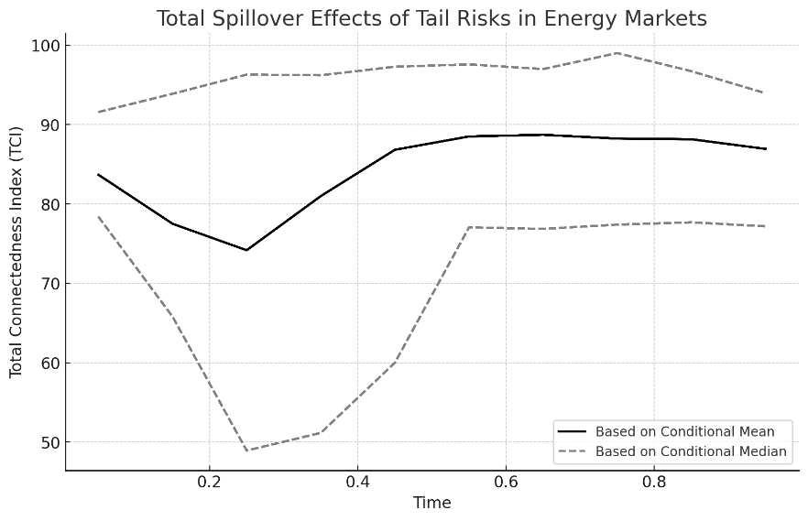

Fig. 3. The total spillover effect of tail risk in the international energy market in the time domain.

Based on **Figure 4**, the net spillover effect of tail risks across assets and quantiles demonstrates the varying intensity of interconnectedness between sectors under different market conditions. The heatmap illustrates the heterogeneity in risk transmission, with darker regions representing stronger spillover effects and lighter regions indicating weaker transmission.

At lower quantiles (e.g., 0.05–0.25), which correspond to extreme falling market conditions, the spillover effects are relatively muted for most sectors, except for **Financials SPSY**, which exhibits significant net spillovers. This suggests that during downturns, financial markets act as a key conduit for risk propagation, likely due to their central role in capital allocation and market liquidity. As the quantiles increase (e.g., 0.5–0.75), representing more stable or average market conditions, the intensity of spillovers grows across sectors. As demonstrated by Managi and Okimoto (2013), dynamic modeling approaches such as QVAR are essential for capturing time-varying spillover effects between markets. The energy sector (**Energy SPNY**) and financial markets emerge as dominant sources of risk, strongly influencing other sectors, such as **Industrials SPLRCI** and **Utilities SPLRCU**. This heightened spillover activity indicates the centrality of these sectors during typical market conditions, reflecting their sensitivity to macroeconomic factors. Dynamic spillovers during major external shocks, such as the COVID-19 pandemic, align with Tiwari et al. (2022), who used TVP-VAR and LASSO models to capture these intensifications At higher quantiles (e.g., 0.85–0.95), corresponding to extreme rising conditions, the spillover effects peak, particularly for **Financials SPSY** and **Energy SPNY**, which exhibit the highest levels of influence across the network. This highlights the amplification of risk contagion during periods of market exuberance, driven by heightened volatility and investor sentiment. Interestingly, green bonds (**SP Green Bond** and **MSCI Green Bond**) maintain relatively low spillover effects across quantiles, showcasing their potential as stabilizing assets in turbulent conditions.

The heatmap emphasizes the asymmetric nature of tail risk spillovers, with pronounced effects during extreme market conditions. This asymmetry underscores the importance of dynamic risk management strategies that account for varying levels of systemic risk under different market scenarios. By identifying the key contributors to risk propagation, this analysis provides critical insights for policymakers and investors to mitigate systemic vulnerabilities effectively.

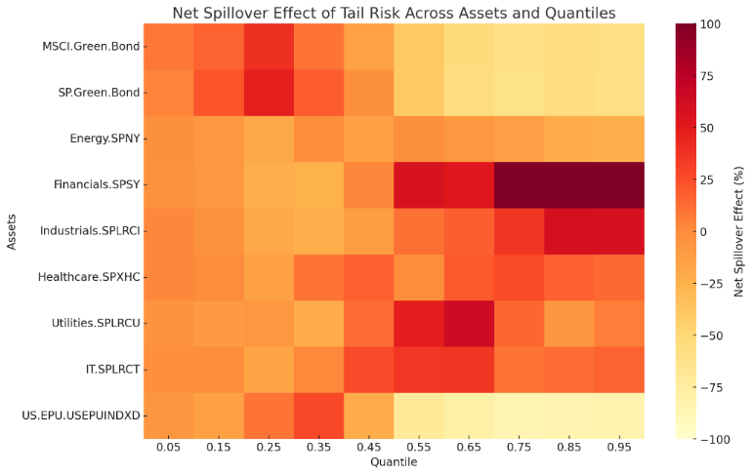

Fig. 4. The total spillover effect of tail risk in the international energy market in the quantile time domain.

Based on **Figure 5**, the total spillover index (TSI) in the frequency domain reveals the dynamic changes in tail risk spillovers across different time horizons within the financial system. The plot demonstrates periodic heterogeneity in risk spillovers, with low-frequency components (20+ days) contributing most significantly to the total tail risk spillover. This dominance underscores that the spillover effect in energy markets is primarily driven by long-term shocks rather than short- or medium-term events. The quantile time-frequency spillover framework, as applied in Chatziantoniou et al. (2022a), is well-suited to analyze risk propagation across varying market states.

In the short-term frequency domain (1–5 days), the spillover effect remains minimal, reflecting limited interdependencies between sectors during immediate market responses. Short-term spillovers are often attributed to isolated events or rapid investor reactions, such as panic selling or speculative trading, which dissipate quickly without widespread contagion. In the medium-term frequency range (5–20 days), spillovers exhibit moderate intensity, highlighting the role of sectoral interlinkages and macroeconomic developments that propagate risks across markets over several weeks. This analysis builds on the framework of Baruník and Křehlík (2018), utilizing their frequency-domain spillover index to study time-frequency risk propagation. During this period, systemic vulnerabilities become more apparent, as cross-sector relationships amplify the effects of market shocks. In contrast, the long-term frequency domain (20+ days) dominates the total spillover effect, illustrating the persistence of tail risks over extended horizons. Long-term spillovers are typically driven by structural economic changes, prolonged policy uncertainty, or major geopolitical events. For instance, events such as the COVID-19 pandemic and ongoing global energy crises have amplified long-term interdependencies, resulting in sustained risk contagion across sectors.

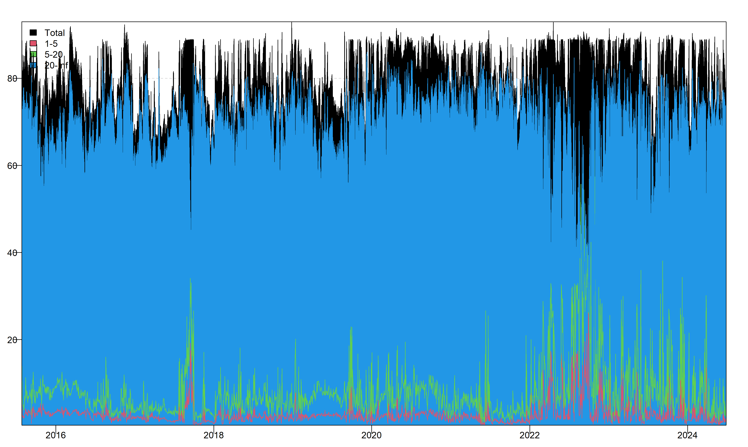

Fig. 5. The total spillover effect of tail risk in the international energy market based on the conditional median in the frequency domain.

The dynamic fluctuations in the total spillover index reflect the evolving nature of systemic risk in the energy market. Peaks in the TSI correspond to periods of heightened uncertainty or extreme events, while troughs indicate relative market stability. These findings emphasize the importance of monitoring long-term risks to manage systemic vulnerabilities effectively and mitigate the cascading effects of extreme events in interconnected markets.

**5.2.2. Directional spillover of tail risk in international energy market**

Figure 6 highlights the dynamic tail risk spillover effects across nine key market indices, showcasing varying degrees of interconnectedness and vulnerability to systemic shocks. Traditional energy markets, particularly **Energy SPNY**, exhibit consistently high spillover peaks, underscoring their central role in risk propagation, especially during periods of global crises like the COVID-19 pandemic or geopolitical conflicts. Financial sectors, represented by **Financials SPSY**, also show frequent and sharp spikes, reflecting their high sensitivity to systemic risks and their role as a key channel for contagion. In contrast, **SP Green Bond** and **MSCI Green Bond** demonstrate relatively lower and more stable spillover effects, reinforcing their resilience during periods of heightened volatility and their utility as hedging instruments. Defensive sectors such as **Healthcare SPXHC** and **Utilities SPLRCU** maintain moderate spillovers, reflecting their partial insulation from broader market shocks due to their regulated or essential nature.

From 2020 onward, the spillover effects intensify significantly across all indices, driven by global disruptions such as the pandemic and geopolitical tensions. This period highlights the systemic interconnectivity of financial and energy markets, with traditional energy sectors and financials acting as primary sources of contagion. Technology sectors like **IT SPLRCT** and policy uncertainty, represented by the **US EPU Index**, show lower direct spillovers but experience heightened activity during extreme events, reflecting broader market instability. These patterns emphasize the importance of robust risk management strategies focused on high-spillover sectors like energy and financials, while green bonds and healthcare sectors remain valuable as stabilizing assets. Policymakers and investors must leverage these insights to mitigate systemic vulnerabilities and build resilience against future market shocks.

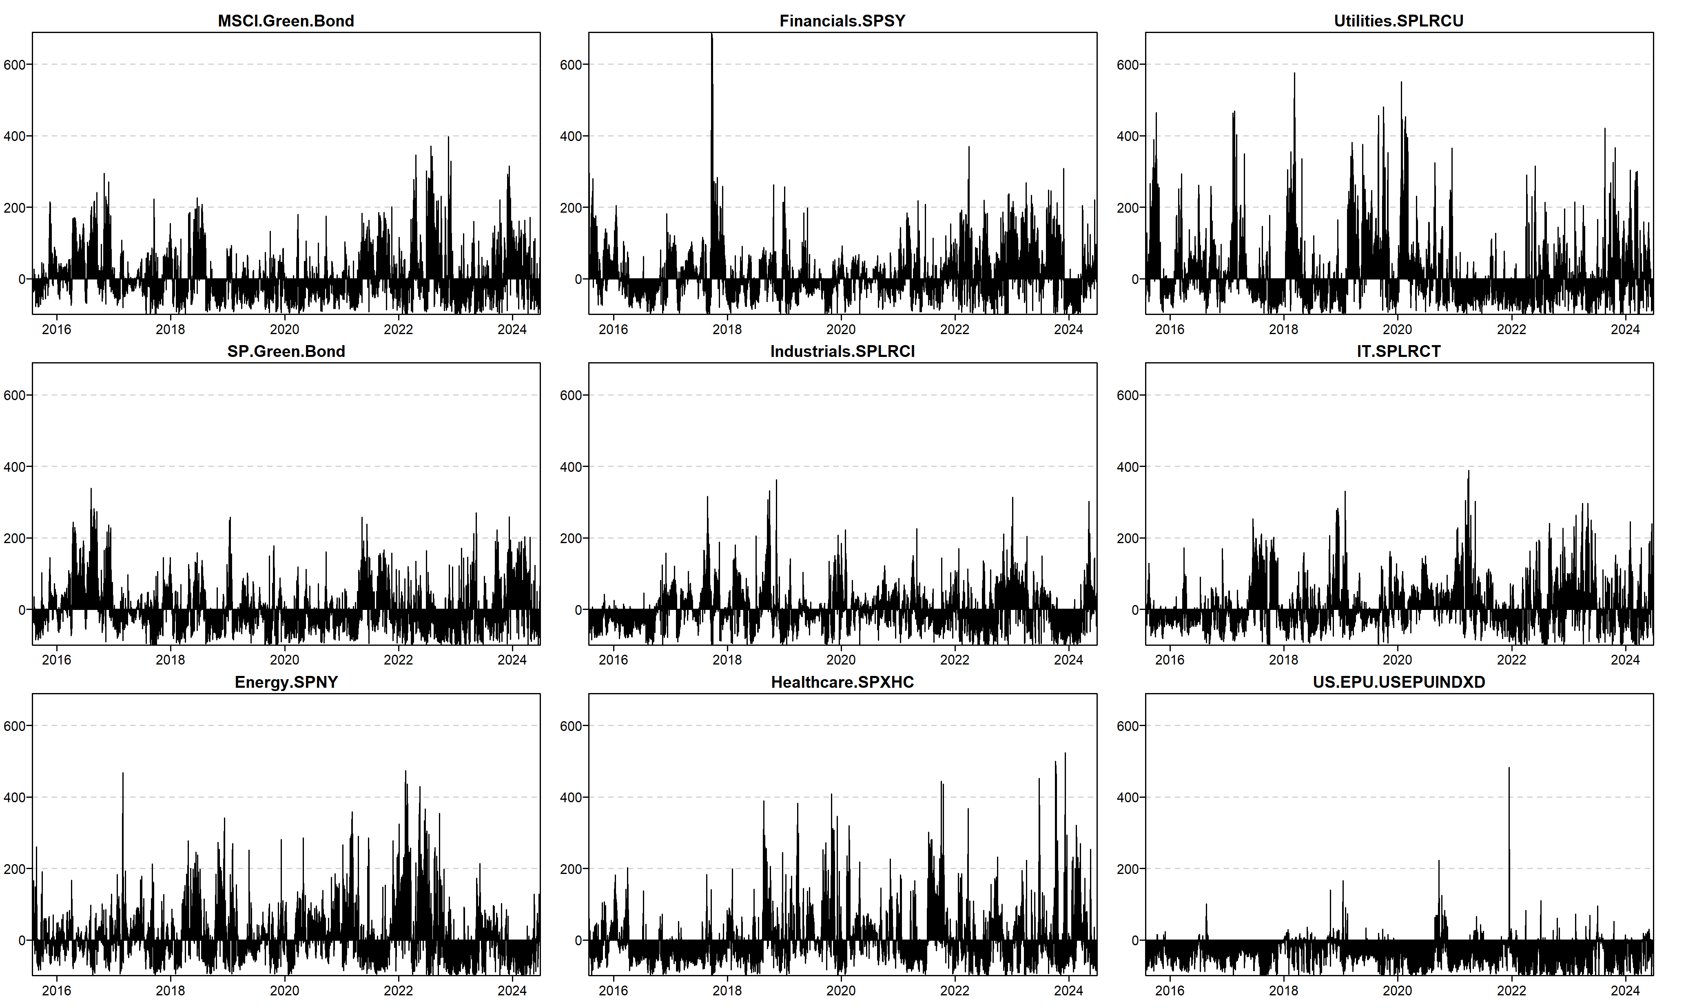

Fig. 6. Tail risk spillover effects of international energy markets in time domain.

Figure 7 illustrates the frequency-domain dynamics of tail risk spillovers across nine key market indices, emphasizing the dominance of long-term spillovers (20+ days) in driving systemic risk across financial and energy markets. Traditional energy sectors like **Energy SPNY**, along with **Industrials SPLRCI** and **Utilities SPLRCU**, exhibit consistently high long-term spillover effects, reflecting their structural influence on interconnected markets. Conversely, green bond markets (**SP Green Bond** and **MSCI Green Bond**) maintain lower spillover levels, showcasing their resilience and hedging potential against systemic shocks. Financial sectors, such as **Financials SPSY**, display notable spillover intensity across all time horizons, with short-term spillovers becoming pronounced during periods of rapid market adjustments. The **US EPU Index** and **IT SPLRCT** highlight the impact of policy uncertainties and technology sector volatility in amplifying market risks. The findings underscore the critical need for long-term risk mitigation strategies targeting high-spillover sectors, while leveraging the stability offered by green bonds to enhance market resilience.

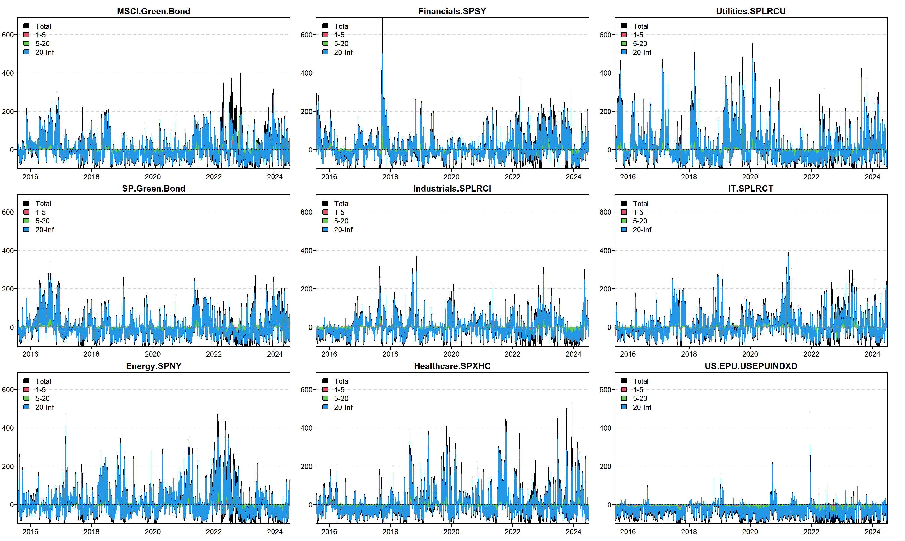

Fig. 7. Tail risk spillover effects of international energy market in the frequency domain.

Figure 8 depicts the tail risk spillover levels across various financial and green bond markets under normal conditions, highlighting their dynamic evolution over time. Traditional markets such as **Energy SPNY** and **Financials SPSY** consistently exhibit higher spillover levels, indicating their dominant role in propagating systemic risks. The persistence of these spillovers underscores the interconnectedness of energy and financial markets, especially during periods of heightened volatility or economic uncertainty.

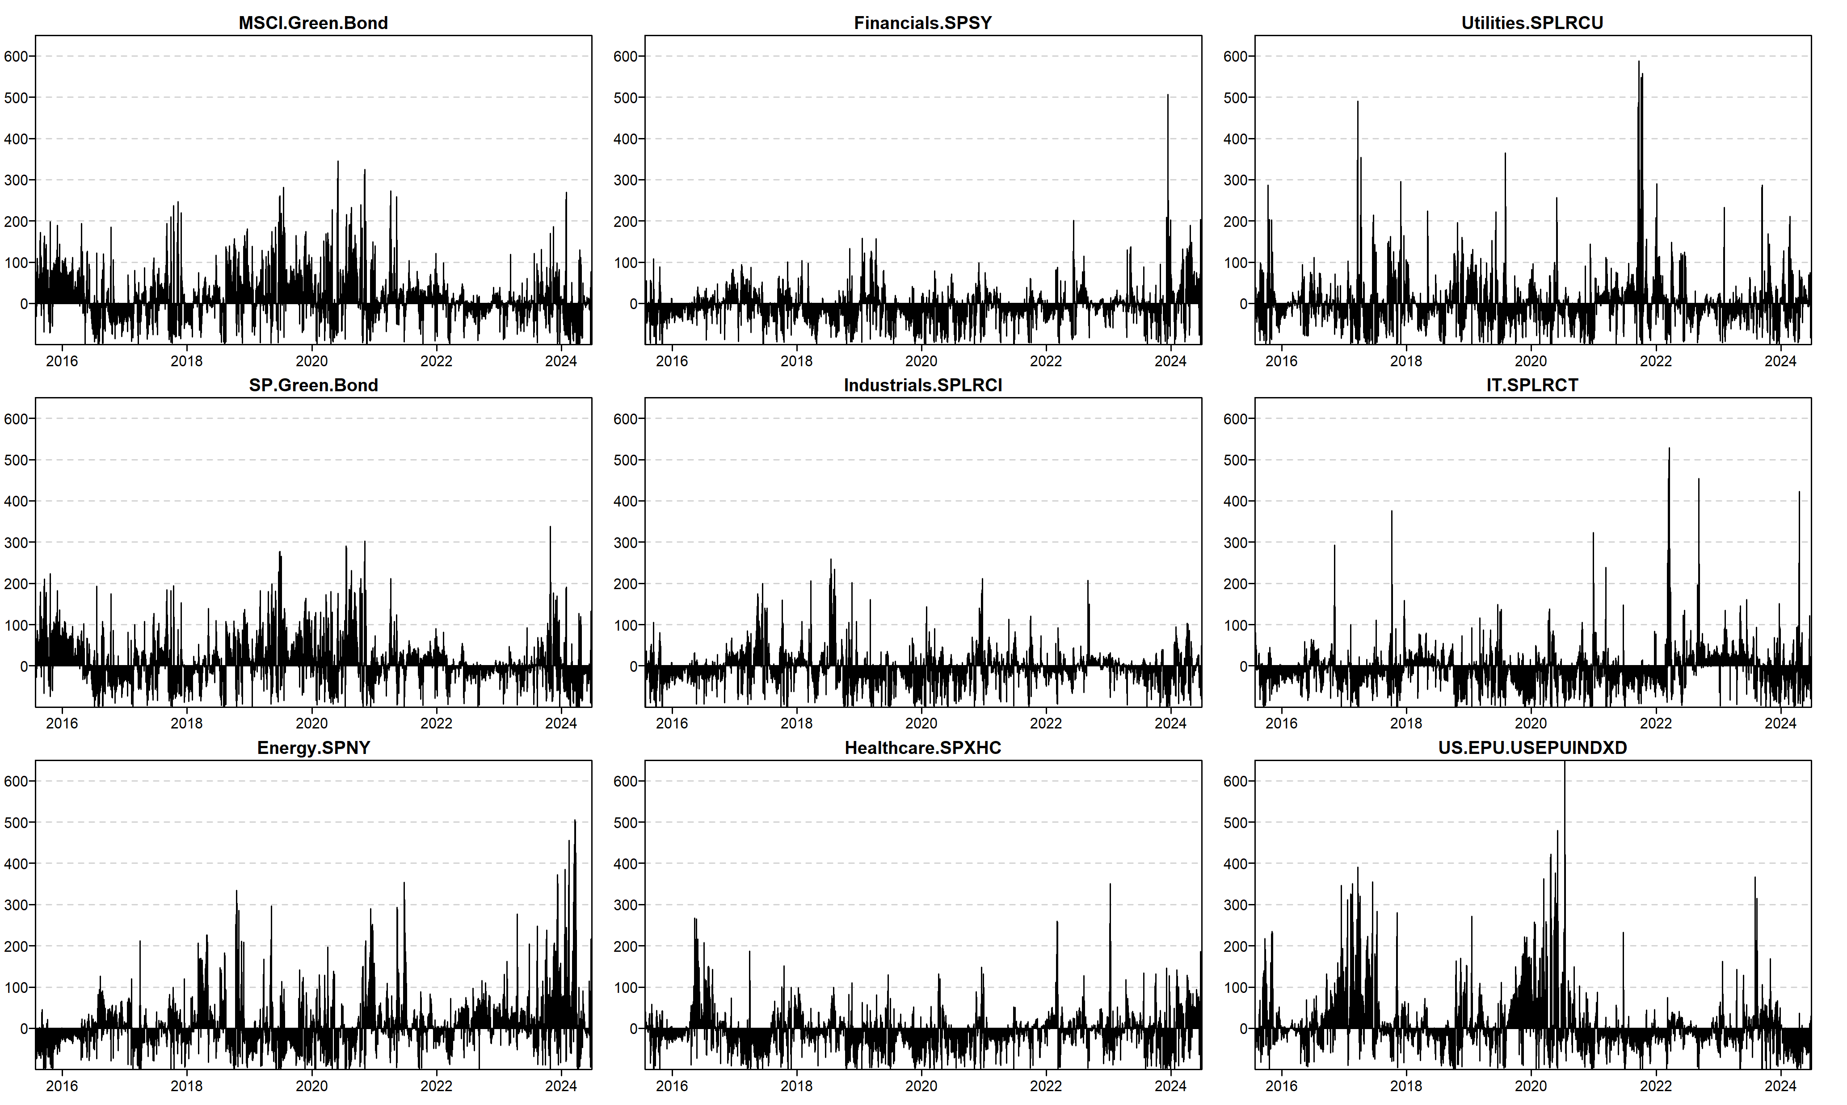

Fig. 8. Tail risk spillover effects in international energy markets in the time domain.

Conversely, green bond markets like **SP Green Bond** and **MSCI Green Bond** demonstrate lower spillover effects, showcasing their resilience and ability to act as stabilizing forces during turbulent periods. Sectors like **Utilities SPLRCU** and **Healthcare SPXHC** maintain moderate and stable spillovers, reflecting their defensive nature and partial insulation from broader market shocks. The lower spillover levels in these sectors highlight their strategic importance for diversification and risk mitigation. These patterns underscore the need for policymakers and investors to account for sector-specific dynamics while promoting the role of green assets in enhancing systemic stability and advancing carbon neutrality goals.

Figure 9 illustrates the dynamics of tail risk spillovers across various financial and energy markets, segmented by short-term (1–5 days), medium-term (5–20 days), and long-term (20+ days) frequency components. The dominance of long-term spillovers (blue-shaded regions) across all indices highlights the persistent nature of systemic risks in interconnected markets. Traditional energy markets, particularly Energy SPNY, exhibit consistently high spillover levels, reflecting their central role in driving systemic contagion, especially during global crises and economic disruptions.

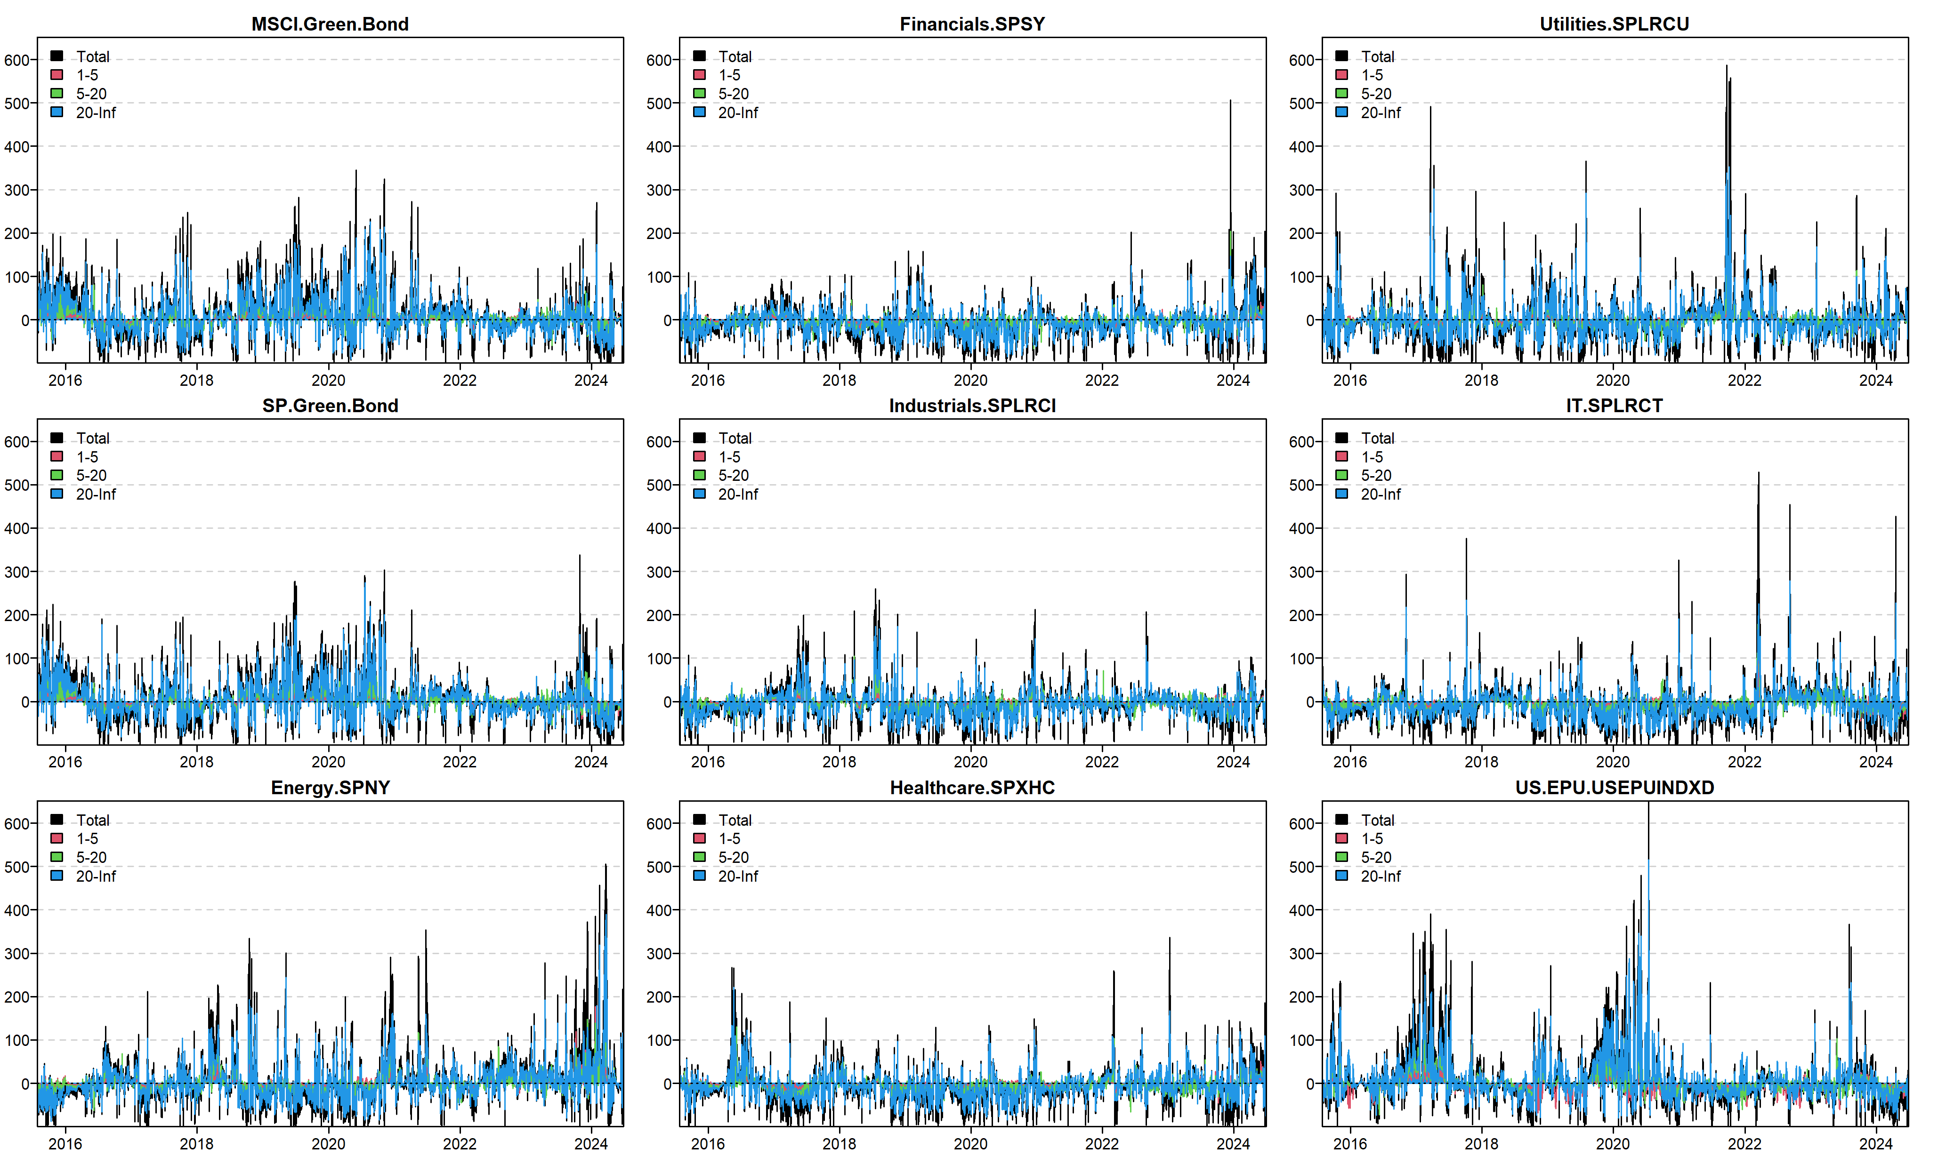

Fig. 9. spillover effect of tail risk in international energy market in frequency domain.

Conversely, green bond markets, such as SP Green Bond and MSCI Green Bond, demonstrate lower spillover intensities across all time horizons, reinforcing their stability and resilience as hedging instruments. Financial sectors like Financials SPSY show significant spillovers across both short and long-term horizons, indicating their sensitivity to systemic shocks and their role as conduits for risk transmission. The stability in sectors like Utilities SPLRCU and Healthcare SPXHC reflects their defensive characteristics, offering insulation from broader market volatility. These findings emphasize the importance of long-term risk mitigation strategies and the integration of green assets into portfolios to enhance resilience and manage systemic vulnerabilities effectively.

**Conclusion**

This study provides an in-depth analysis of tail risk contagion and volatility spillovers in international energy markets, focusing on the interactions between green bonds, traditional energy sectors, and other sectoral indices. Employing advanced econometric techniques, including the ARMA-EGARCH-Skew-t model and the quantile time-frequency spillover framework, the research highlights the complexities of risk propagation under various market conditions. By examining both static and dynamic spillover effects, the study unveils critical insights into how systemic risks flow through interconnected markets during extreme economic scenarios. The findings underscore the central role of traditional energy markets, particularly the Energy SPNY index, as key risk transmitters across financial and industrial sectors. These markets exhibit the highest levels of spillover intensity during extreme market states, both downturns and booms, amplifying systemic vulnerabilities. In contrast, green bonds act as stabilizing agents under stressful market conditions, offering a hedge against traditional energy volatility. However, their role reverses during market upswings, where green bonds become significant absorbers of external shocks, signalling their dependence on broader market dynamics. This dual behaviour highlights the need for careful risk management strategies when incorporating green finance into diversified portfolios. Dynamic and frequency domain analyses provide additional layers of understanding, revealing distinct patterns across short-term, medium-term, and long-term horizons. Short-term spillovers are limited and largely localized to sector-specific events. In the medium-term, the interconnectedness between markets intensifies, with traditional energy markets emerging as major contributors to systemic risk. Long-term analysis reveals persistent and structural risk spillovers, driven by geopolitical uncertainties, regulatory shifts, and prolonged economic instability. Traditional energy markets dominate this horizon, while clean energy sectors maintain relative resilience, underscoring the importance of long-term systemic risk monitoring. The asymmetric nature of spillovers is particularly pronounced between traditional and clean energy markets. Clean energy sectors, while less interconnected under normal conditions, display heightened vulnerability during global crises. This behaviour reinforces the importance of transitioning to sustainable energy systems while managing the inherent risks associated with both traditional and clean energy markets. The study’s findings also highlight the stabilizing potential of green bonds in turbulent markets, even as their role shifts under extreme positive conditions. These results carry significant implications for policymakers and investors. The systemic dominance of traditional energy markets necessitates regulatory frameworks that encourage diversification and the integration of green finance. Tailored strategies must address the vulnerabilities revealed by asymmetric spillovers, ensuring that both clean and traditional energy markets are equipped to withstand systemic shocks. Policymakers should focus on leveraging the stabilizing properties of green bonds while mitigating their susceptibility to external risks during economic expansions.

In conclusion, this research sheds light on the evolving dynamics of risk spillovers in energy markets, emphasizing the critical role of green finance in fostering market resilience. By combining advanced methodologies with detailed empirical analysis, the study provides actionable insights for navigating the complexities of a rapidly transforming energy and financial landscape. Future research should explore the influence of emerging technologies and policy innovations on these dynamics, ensuring a comprehensive understanding of risk propagation in a world increasingly oriented toward sustainability.

**Appendix**

The net pairwise spillover effects in Fig. A1 illustrate the time-domain dynamics of tail risk transmission across various sectors, including green bonds, utilities, and traditional financial markets. The magnitude and direction of spillovers fluctuate over time, with significant peaks observed during periods of heightened market uncertainty. For instance, green bonds and financials show persistent spillovers, demonstrating the interconnectedness between sustainable finance and conventional market dynamics. The time-domain analysis underscores the evolving nature of risk propagation influenced by external shocks and structural changes in market conditions.

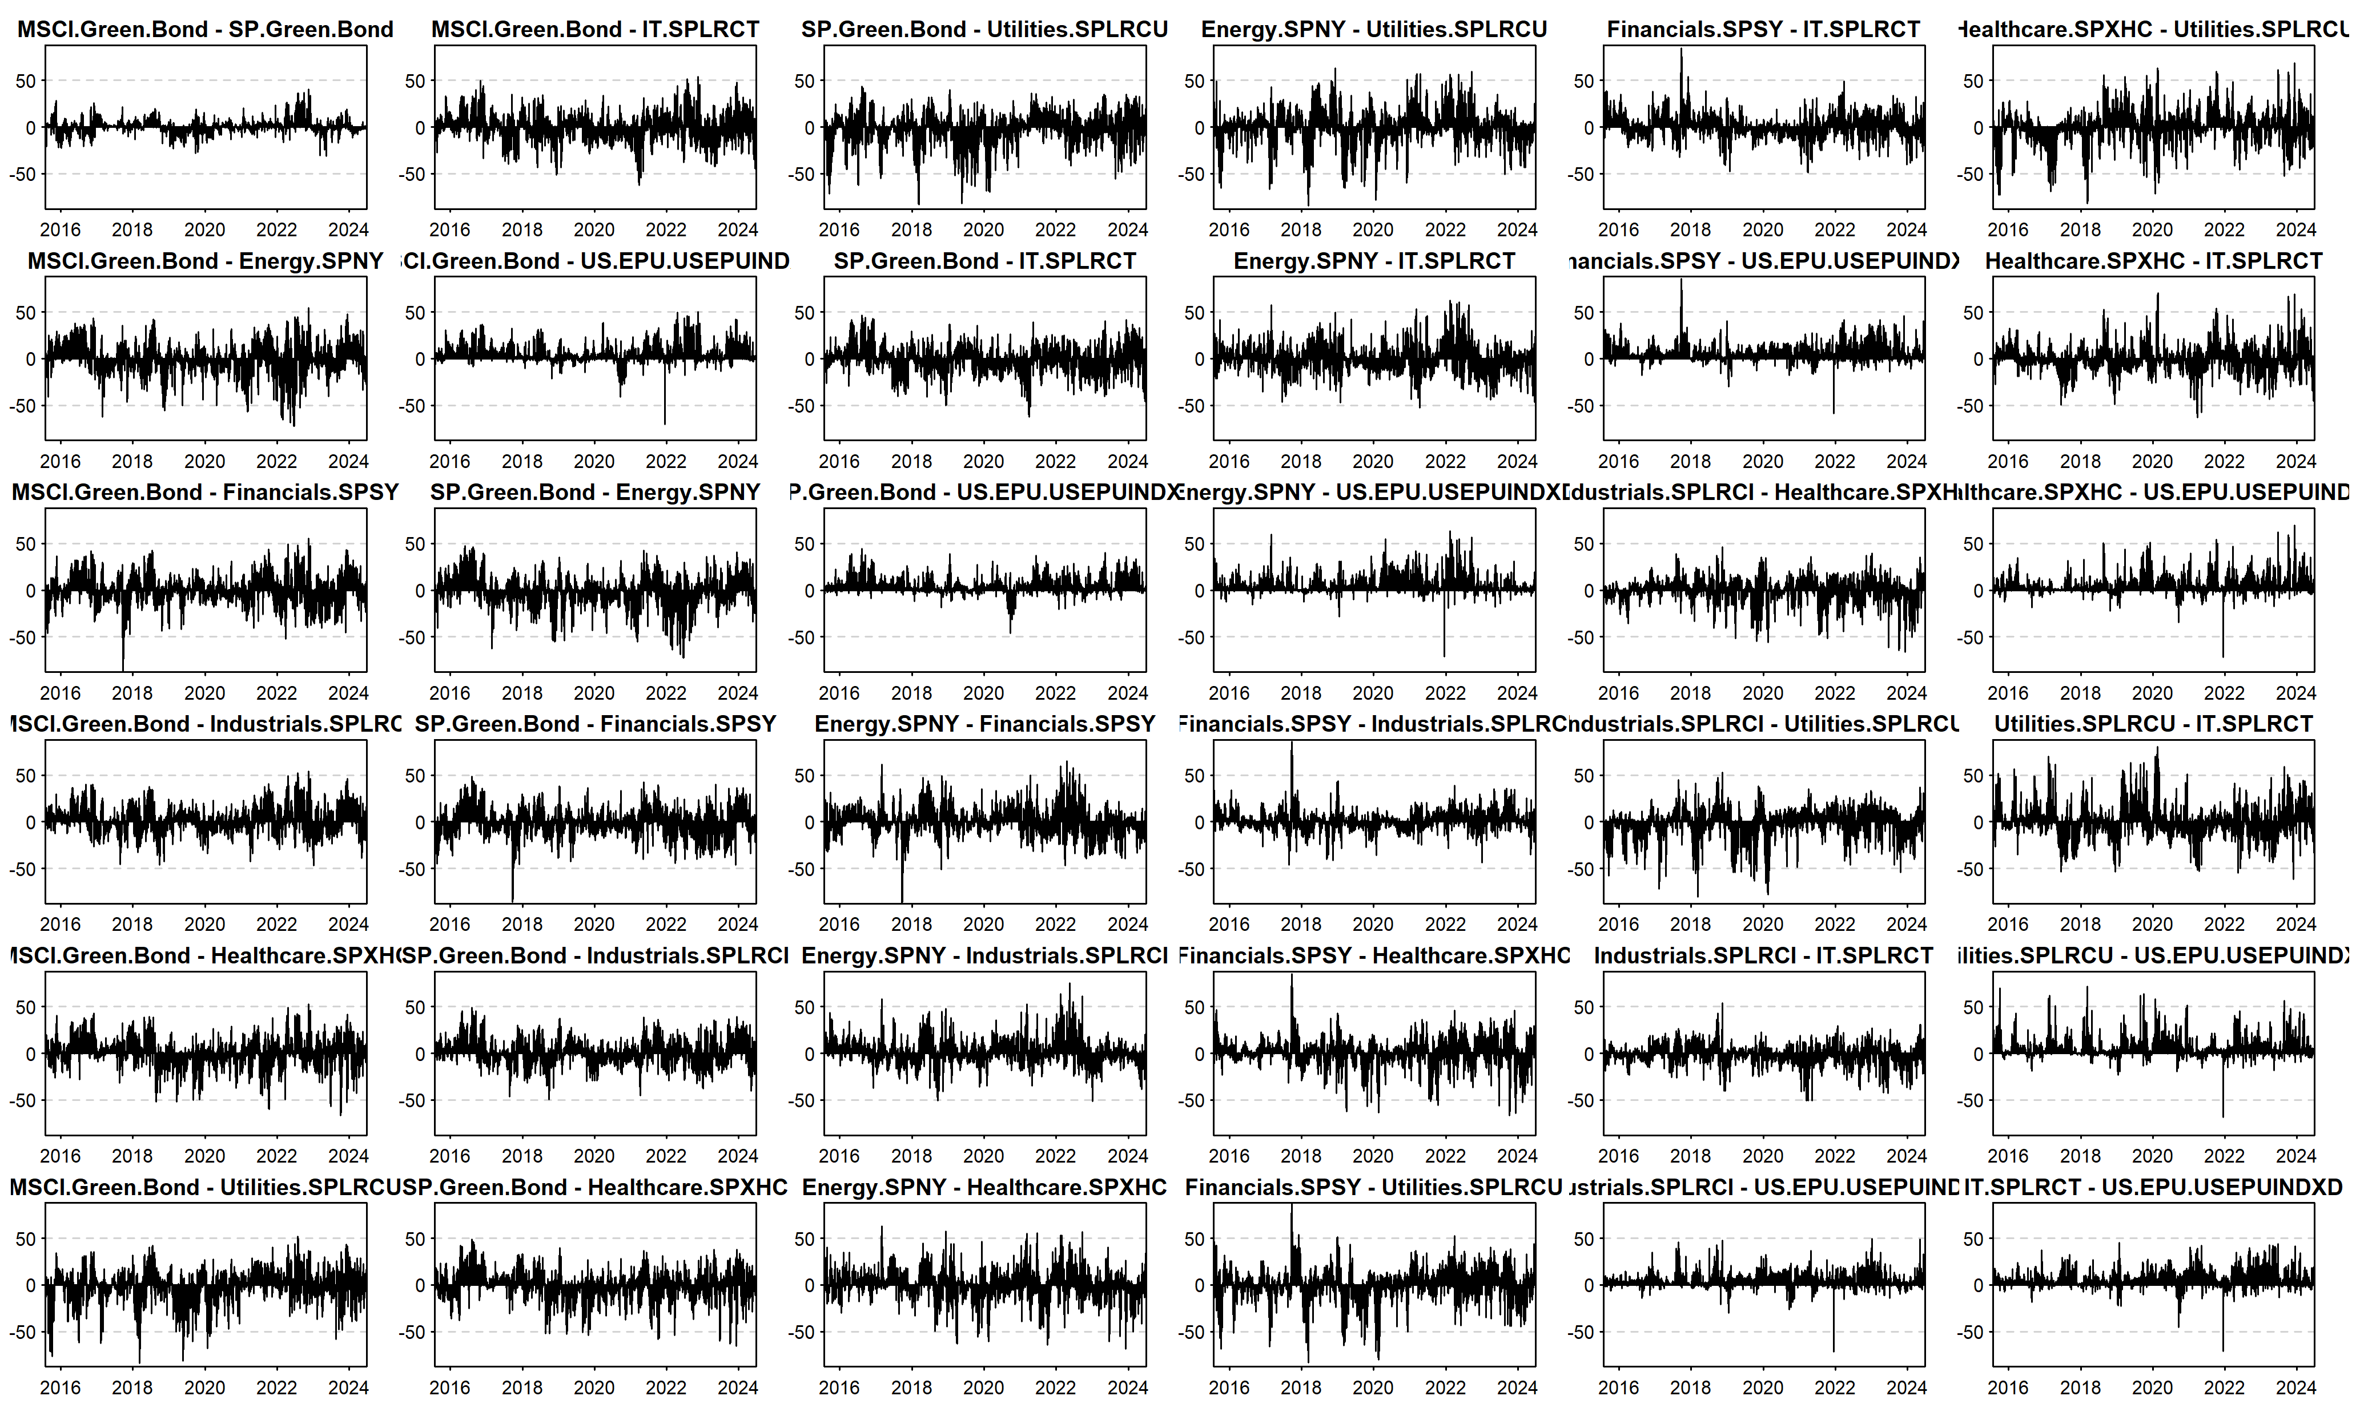

Fig. A1. Net pairwise spillover effects of tail risks in the international energy market in the time domain.

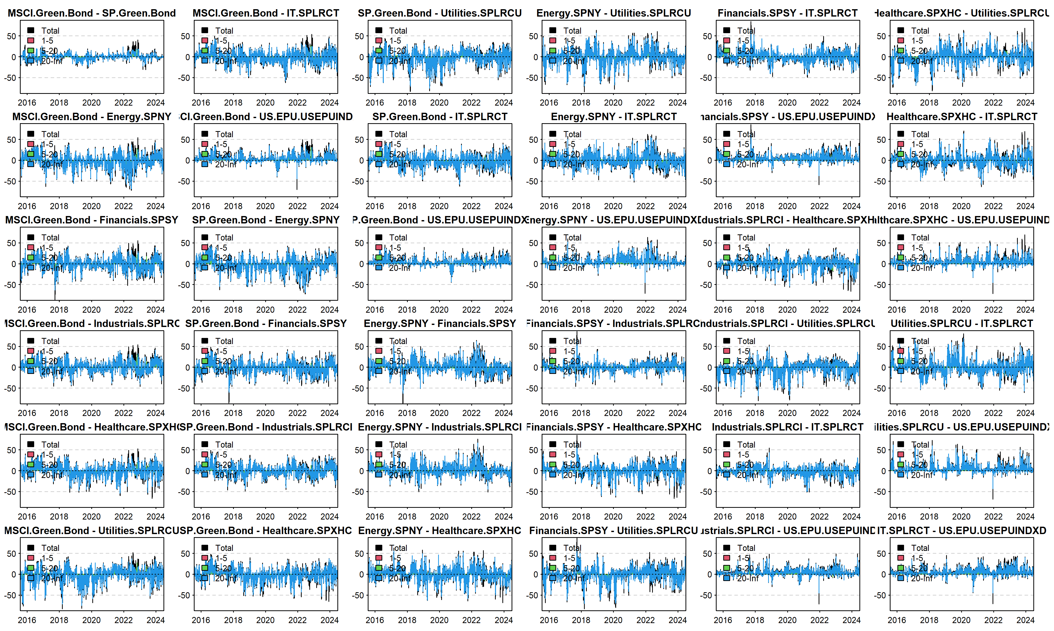

Fig. A2. Net pairwise spillover effects of tail risks in international energy markets in the frequency domain.

Fig. A2 extends the analysis by examining the frequency-domain dynamics of net tail risk spillovers. The decomposition into short- and long-term spillover effects reveals distinct patterns. Long-term spillovers are dominant, highlighting the sustained risk transmission across markets, especially between green bonds and traditional sectors such as financials and industrials. Short-term spillovers are more volatile, reflecting immediate responses to market shocks. The frequency-domain perspective emphasizes the structural role of green finance in influencing broader market stability and the critical feedback loops between sectors under varying temporal horizons.

**Reference**

•  Adcock, C. J. (2014). Mean–variance–skewness efficient surfaces, Stein’s lemma and the multivariate extended skew-student distribution. *European Journal of Operational Research, 234*(2), 392-401. [https://doi.org/10.1016/j.ejor.2013.12.015](https://www.sciencedirect.com/science/article/pii/S0377221713005706)

•  Ahmed, R., Chaudhry, S. M., Kumpamool, C., & Benjasak, C. (2022). Tail risk, systemic risk and spillover risk of crude oil and precious metals. *Energy Economics*, *106063*. [https://doi.org/10.1016/j.eneco.2021.106063](https://www.sciencedirect.com/science/article/pii/S0140988321004488)

•  Ando, T., Greenwood-Nimmo, M., & Shin, Y. (2022). Quantile connectedness: Modeling tail behavior in the topology of financial networks. *Management Science, 68*(4), 2401-2431. https://doi.org/10.1287/mnsc.2020.3758

•  Asadi, M., Roubaud, D., & Tiwari, A. K. (2022). Volatility spillovers amid crude oil, natural gas, coal, stock, and currency markets in the US and China based on time and frequency domain connectedness. *Energy Economics, 109*, 105961. [https://doi.org/10.1016/j.eneco.2021.105961](https://www.sciencedirect.com/science/article/pii/S0140988321001726)

•  Atukeren, E., Çevik, E. İ., & Korkmaz, T. (2021). Volatility spillovers between WTI and Brent spot crude oil prices: An analysis of Granger causality in variance patterns over time. *Research in International Business and Finance, 56*, 101385. [https://doi.org/10.1016/j.ribaf.2019.101385](https://www.sciencedirect.com/science/article/pii/S0275531919308414)

•  Baruník, J., & Křehlík, T. (2018). Measuring the frequency dynamics of financial connectedness and systemic risk. *Journal of Financial Economics, 16*(2), 271-296. [https://doi.org/10.1016/j.jempfin.2018.01.002](https://www.sciencedirect.com/science/article/pii/S0304405X17301631)

•  Benoit, S., Colliard, J. E., Hurlin, C., & Pérignon, C. (2017). Where the risks lie: A survey on systemic risk. *Review of Financial Studies, 21*(1), 109-152. https://doi.org/10.1093/rfs/hhw070

•  Bhattacharya, M., Paramati, S. R., Ozturk, I., & Bhattacharya, S. (2016). The effect of renewable energy consumption on economic growth: Evidence from top 38 countries. *Applied Energy, 162*, 733-741. [https://doi.org/10.1016/j.apenergy.2015.10.104](https://www.sciencedirect.com/science/article/pii/S0306261915012265)

•  Billah, M., Karim, S., Naeem, M. A., & Vigne, S. A. (2022). Return and volatility spillovers between energy and BRIC markets: Evidence from quantile connectedness. *Research in International Business and Finance, 101680*. [https://doi.org/10.1016/j.ribaf.2022.101680](https://www.sciencedirect.com/science/article/pii/S0275531922000922)

•  Bondia, R., Ghosh, S., & Kanjilal, K. (2016). International crude oil prices and the stock prices of clean energy and technology companies: Evidence from non-linear cointegration tests with unknown structural breaks. *Energy, 101*, 558-565. [https://doi.org/10.1016/j.energy.2016.02.039](https://www.sciencedirect.com/science/article/pii/S0360544216311579)

•  Bouri, E., Saeed, T., Vo, X. V., & Roubaud, D. (2021). Quantile connectedness in the cryptocurrency market. *Journal of International Financial Markets, Institutions and Money, 71*, 101302. [https://doi.org/10.1016/j.intfin.2020.101302](https://www.sciencedirect.com/science/article/pii/S1042443120301835)

•  Campiglio, E., Dafermos, Y., Monnin, P., Ryan-Collins, J., & Schotten, G. (2018). Climate change challenges for central banks and financial regulators. *Nature Climate Change, 8*(6), 462-468. [https://doi.org/10.1038/s41558-018-0175-0](https://www.nature.com/articles/s41558-018-0175-0)

•  Chatziantoniou, I., Gabauer, D., & Stenfors, A. (2021). Interest rate swaps and the transmission mechanism of monetary policy: A quantile connectedness approach. *Economics Letters, 204*, 109891. [https://doi.org/10.1016/j.econlet.2021.109891](https://www.sciencedirect.com/science/article/pii/S0165176521001683)

•  Chatziantoniou, I., Abakah, E. J. A., Gabauer, D., & Tiwari, A. K. (2022a). Quantile time-frequency price connectedness between green bond, green equity, sustainable investments and clean energy markets. *Journal of Cleaner Production*, 132088. [https://doi.org/10.1016/j.jclepro.2022.132088](https://www.sciencedirect.com/science/article/pii/S0959652622004137)

•  Chatziantoniou, I., Gabauer, D., & de Gracia, F. P. (2022b). Tail risk connectedness in the refined petroleum market: A first look at the impact of the COVID-19 pandemic. *Energy Economics, 111*, 106051. [https://doi.org/10.1016/j.eneco.2022.106051](https://www.sciencedirect.com/science/article/pii/S0140988322001191)

•  Chen, H., Xu, C., & Peng, Y. (2022). Time-frequency connectedness between energy and nonenergy commodity markets during COVID-19: Evidence from China. *Research Policy, 78*, 102874. [https://doi.org/10.1016/j.respol.2022.102874](https://www.sciencedirect.com/science/article/pii/S0048733322001444)

•  Dawar, I., Dutta, A., Bouri, E., & Saeed, T. (2021). Crude oil prices and clean energy stock indices: Lagged and asymmetric effects with quantile regression. *Energy Economics, 56*, 101680. [https://doi.org/10.1016/j.eneco.2020.101680](https://www.sciencedirect.com/science/article/pii/S0140988321003456)

•  Diebold, F. X., & Yilmaz, K. (2012). Better to give than to receive: Predictive directional measurement of volatility spillovers. *International Journal of Forecasting, 28*(1), 57-66. [https://doi.org/10.1016/j.ijforecast.2011.02.006](https://www.sciencedirect.com/science/article/pii/S0169207011001224)

•  Andersen, T. G., Bollerslev, T., Diebold, F. X., & Vega, C. (2007). Real-time price discovery in global stock, bond and foreign exchange markets. *Journal of International Economics, 73*(2), 251-277. [https://doi.org/10.1016/j.jinteco.2007.02.004](https://www.sciencedirect.com/science/article/pii/S0022199607000473)

•  Zhu, Q., You, M., & Wu, S. (2020). Cross-market volatility spillovers: Evidence from the COVID-19 pandemic. *Finance Research Letters, 41*, 101857. [https://doi.org/10.1016/j.frl.2020.101857](https://www.sciencedirect.com/science/article/pii/S1544612320315907)